**ACTIVITY: Shaky New Zealand**

**Activity idea**

In this activity, students use maps to plot a graph of earthquakes under New Zealand to show the shape of the North Island subduction zone and compare this to the distribution of earthquakes in the South Island.

By the end of this activity, students should be able to:

* read a map legend to understand the distribution of earthquakes in New Zealand
* use earthquake distribution data for plotting
* gain an understanding of the subduction zone where the Pacific plate is plunging below the Australian plate
* draw a simple sketch of what the plate boundary might look like at the bottom of the South Island.

This activity was developed for the Earthquake Commission (EQC) and has been kindly provided for use on the Science Learning Hub.



Introduction/background

What you need

What to do

Student instructions

Map of New Zealand showing location of earthquakes

Spread of earthquakes at different depths

**Introduction/background**

This activity looks at the different structures of the tectonic plate boundary in the North and South Islands.

We cannot directly observe the plate boundary under New Zealand, but we can make measurements of earthquakes at the surface and use the information to gain a picture of what is happening below the surface.

**What you need**

* Student instructions
* Map of New Zealand showing location of earthquakes
* Spread of earthquakes at different depths – blank graph

**What to do**

1. Hand out copies of the Student instructions, Map of New Zealand showing location of earthquakes and Spread of earthquakes at different depths.
2. Have students complete the first page (steps 1–5). There is quite a lot of overlap between the distributions of the earthquakes at different depths. This overlap has been reduced to make drawing the graph easier – the resulting graph is a simplified representation of the subduction zone, but students will still be able to understand how the technique works.
3. Encourage discussion about what the graph represents. (The subduction zone where the Pacific plate in the east is plunging below the Australian plate in the west.) The main thing for students to notice about the distribution of earthquakes in the North Island is that the shallower ones are in the east, getting deeper towards the west.

The finished graph should look something like this:

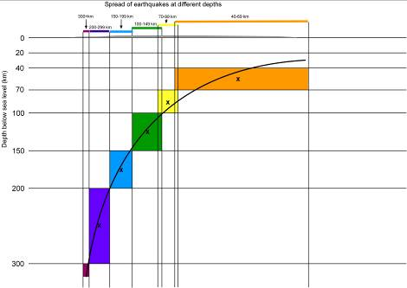

The distribution map and graph do not include shallow earthquakes less than 40km deep. There are a great many of these shallow earthquakes each year, but they tend to be associated with the rupturing of faults near the surface, rather than with direct movement of the deep subducting plates. They therefore do not fit into the pattern of deep quakes.

***Creating maps of New Zealand earthquake distribution using GeoNet***

You can obtain up-to-date distribution maps of these shallower earthquakes, and maps showing different depths plotted separately rather than together, on the GeoNet website ([http://magma.geonet.org.nz/resources/quakesearch](http://magma.geonet.org.nz/resources/quakesearch/)).

As an example, to obtain a map showing earthquakes from 2008 to 2009, down to 39km deep, over the whole of New Zealand, define your search:

* From year – 2008
* To year – 2009
* Location – leave empty
* Minimum depth – 0
* Maximum depth – 39
* Magnitude – leave empty
* Quality – leave empty
* Output format – select ‘Map (JPEG)’
* Click on ‘Submit’.
* The map will be created in a separate window. Right click on the image to save it.

You can change the definitions to get maps for different years, depths, magnitudes etc.

1. After graphing the North Island subduction zone, ask the students to complete the second page (steps 6–8) to compare distribution patterns between North and South Islands. There are a number of things for them to notice:

* The pattern in the north of the South Island is like a continuation of the North Island earthquake distribution.
* There is a large part of the South Island that has experienced very few deeper earthquakes in the last few years.
* In the south, earthquakes are deeper in the east than the west – this is the opposite to the North Island.

1. Encourage a discussion about what might cause the differences.

There is a ‘gap’ in the South Island because there is no subduction zone there. Instead, along the Alpine Fault, the Pacific plate is sliding southwards past the Australian plate, and is also pushing upwards to form the Southern Alps. The movement is gradual – it seems that the plate boundary is ‘locked’ at the moment, since large earthquakes only seem to happen every one or two hundred years.

The earthquake distribution in the far south seems to suggest that there is a subduction zone, with the Australian plate moving under the Pacific plate (the opposite to the North Island). However, not all geologists agree with this, and the issue has yet to be resolved.

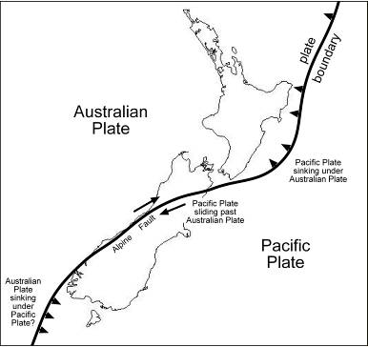

Movements of the tectonic plate boundary near New Zealand

**Student instructions**

You should have:

* a map showing the distribution of earthquakes in New Zealand in the years 2006–2007
* a blank graph to plot the spread of earthquakes at different depths.

**North Island plate boundary**

1. Look at the map of New Zealand showing earthquakes (use the legend to help) and study the distribution of earthquakes in the North Island.

* Are the deepest earthquakes in the east or west?
* Where are the shallower earthquakes?
* What does this pattern tell us about the structure of the Earth below New Zealand?

You can use data of earthquake depth to get an idea of what is happening below New Zealand. (The total number of earthquakes recorded in the area is very large, so the records on the graph have been simplified to provide a general idea.)

1. Look on the top line of the blank graph for the spread of earthquakes at different depths:

* The low, grey shape represents a west-east cross-section of the North Island of New Zealand.
* Above this are bars showing the distribution of earthquakes at different depths. The colours are the same as on the map.

1. Start with the green bar (100–149km):

* Draw a light vertical line down from each end of the green bar.
* Colour in green the rectangle between these two lines, with the 100km horizontal line at the top and 150km at the bottom. It should look something like this:



1. Now do the same for all the other coloured bars. When you have finished, you will have an approximate cross section showing the depths at which earthquakes occur beneath the North Island of New Zealand.
2. Now put a small cross in the centre of each coloured rectangle and draw a smooth curve along the line of the crosses – the line doesn’t have to actually go through each cross, but near. This line marks the approximate position of where the Pacific plate slides down under the Australian plate below the North Island – this is called a subduction zone.

**South Island plate boundary**

1. Look again at the map of New Zealand showing earthquakes in 2006 and 2007. This time, look for patterns in the South Island data.

* What pattern do the earthquakes show at the top of the South Island? (Are the deeper earthquakes in the east or west?)
* What pattern do the earthquakes show at the bottom of the South Island? (Are the deeper earthquakes in the east or west?)
* What happens in between?

1. Draw a simple sketch of what you think the plate boundary might look like at the bottom of the South Island.
2. You may have noticed that not many earthquakes were recorded in the central South Island. That is because the plates are not subducting under each other here. Instead, the plates meet at a major fault. This means the Pacific plate in the east is sliding horizontally past the Australian plate, and it is also rising.

* What major geological feature has resulted from the movement along this fault?

