ACTIVITY: Plates and quakes

Activity idea

In this activity, students take on the roles of seismologists, vulcanologists and geographers, using maps to look for patterns in the worldwide distribution of earthquakes, volcanoes and topographic features.

By the end of this activity, students should:
- see patterns in the worldwide distribution of earthquakes, volcanoes and topographic features and develop an understanding of the idea of a dynamic Earth
- understand that New Zealand’s location on a plate boundary explains why the country has so many earthquakes and volcanoes
- be able to relate their findings to the positions of tectonic plates and their boundaries
- be able to predict where future earthquakes might occur, use the latitude and longitude co-ordinates to plot the locations of earthquakes, compare with existing patterns and explain any new observations
- understand that specialists collaborate to provide evidence to support their ideas.

This activity was developed for the Earthquake Commission (EQC) and has been kindly provided for use on the Science Learning Hub.

Introduction/background
What you need
What to do
Extension ideas
Part 1 – seismologist instructions
Part 1 – vulcanologist instructions
Part 1 – geographer instructions
Part 2 – specialists working together instructions
World map for vulcanologists
World map for seismologists
World map for geographers
World map showing main tectonic plates
Part 3 – predicting earthquakes

Introduction/background

This activity is aimed at introducing students to the idea of a dynamic Earth; it is not an in-depth study of plate tectonics and Earth structure. They look for relationships between the plate boundaries and their data.

They also relate the position of New Zealand to the occurrence of earthquakes and volcanoes.

They will see where New Zealand fits global patterns, and help answer questions such as:
- Does everywhere in the world get earthquakes?
- Why do we get earthquakes in New Zealand?

Nature of science
The format of this activity reflects several aspects of the nature of science strand of the science curriculum:
- Investigating in science: students collect evidence, interpret it, and develop and support their ideas.
- Understanding about science: students will experience working in teams of scientists.
- Communicating in science: students will extend their scientific vocabulary of text, symbols and conventions.

What you need

For each group of 6 students, a copy of:
- Part 1 – seismologist instructions
- Part 1 – vulcanologist instructions
- Part 1 – geographer instructions
- Part 2 – specialists working together instructions
- World map for vulcanologists (works best in colour)
- World map for seismologists (works best in colour)
- World map for geographers (works best in colour)
- World map showing main tectonic plates (works best as a clear overhead transparency)
- Part 3 – predicting earthquakes

What to do

- Explain that the students are going to take on the roles of seismologists, vulcanologists and geographers. You could get your students to research and discuss what they think these different scientists do. (Seismologists study earthquakes, vulcanologists study volcanoes, geographers study topology – surface features on land and beneath the sea.) Each specialist will be relied on later to pass on information they have gathered, so this will only work if everyone plays their part.

- Divide the class into groups of 6. In each group, designate 2 students as seismologists, 2 as vulcanologists and 2 as geographers. These pairs will work separately to start with, and reform as a group later.
- Give the seismologists Part 1 – seismologist instructions and World map for seismologists.
- Give the vulcanologists Part 1 – vulcanologist instructions and World map for vulcanologists.
- Give the geographers Part 1 – geographer instructions and World map for geographers
The maps do not have country or region names on them, so you might like to have a general world map somewhere in the room for students to refer to.

- In their specialist pairs, students look at their map and answer Part 1 questions.

- Reassemble the groups of 6. The specialists need to share what they have discovered:
- Is there a relationship between the distribution of earthquakes, volcanoes and elevation?
- What might cause the patterns they have observed?

- Now give each group Part 2 – Specialists working together instructions and World map showing main tectonic plates (if the map is a transparency, they can lay it over and line it up with their data maps).

- In their groups of 6, students look at their map and answer Part 2 questions.

Where on the plates do most earthquakes and volcanoes happen?
- Most earthquakes and volcanoes are located along plate boundaries, where active movement of the Earth’s crust is taking place.
Name a plate boundary where there are more earthquakes than volcanoes.
- Eurasian plate/African plate – Europe, especially Mediterranean.
- South American plate/African plate, and several others where the boundary is in mid-ocean.
- Eurasian plate/Indian plate – Himalayas.

Name a plate boundary where there are more volcanoes than earthquakes.
- North American plate/Eurasian plate – Iceland.
- There is a group of volcanoes in east Africa where there is not a plate boundary. This is the East African Rift Valley, where the African plate is being split into two separate plates.
How does the position of New Zealand account for its earthquakes and volcanoes?
- New Zealand is on the boundary between the Australian and Pacific plates, which explains why the country has so many earthquakes and volcanoes.

- Explain to your students that you are about to give them the locations of some earthquakes to plot. Ask them to predict where they might/might not occur in the world. Make sure that they explain their prediction within the group.

- Hand out Part 3 – predicting earthquakes and have the students these on their existing seismology maps (how to plot latitude and longitude is included in the student instructions).

Date | Latitude | Longitude | Magnitude | Depth (km) | Region/country
14-Nov-2007 | -23 | -70 | 7.7 | 60 | Northern Chile
14-Nov-2007 | 31 | 142 | 5.0 | 27 | South of Japan
7-Nov-2007 | 22 | 92 | 5.2 | 27 | NE India
27-Oct-2007 | 38 | 21 | 5.0 | 10 | Greece
27-Oct-2007 | -20 | -178 | 4.5 | 475 | Fiji

The examples provided are older data so you can choose some more recent earthquakes from website. You will find information on earthquakes that have happened around the world in the last 30 days at www.iris.edu/seismon/last30days.phtml and a world map of recent earthquakes at www.iris.edu/dms/seismon.htm.

Point out that the earthquakes in the table were at different depths, and ask why they think this was. It is important for students to realise that plate boundaries are not just lines at the surface, they are 3D structures that extend deep below the surface.

Extension ideas

Keep a larger copy of the earthquake map on the classroom wall. If students are tracking earthquakes on a daily basis, they can add information each day/week to this map throughout the study.

Carry out some research on plate tectonics (for example, at
http://academickids.com/encyclopedia/index.php/Plate_tectonics):
- Find out why earthquakes and volcanoes occur at or near plate boundaries and the role of plates in mountain building.
- Investigate different types of plate boundaries – what are the distributions of earthquakes and volcanoes at converging, diverging and transform boundaries?
Part 1 – seismologist instructions
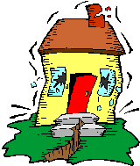
You are seismologists – earthquake specialists.

Look carefully at the map you have been given.

What does this map show you?

Describe any patterns that you see in the data (such as groups or lines of dots, concentrations of different colours).

Which parts of the world get the most earthquakes?

Which parts of the world get the deepest earthquakes?

Which parts of the world don’t get earthquakes?

What do you think might cause the patterns of earthquakes?

Part 1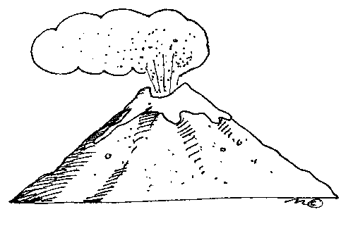– vulcanologist instructions

You are vulcanologists – volcano specialists.

Look carefully at the map you have been given.

What does this map show you?

Describe any patterns that you see in the data (such as groups or lines of dots).

Which parts of the world have the most volcanoes?

Which parts of the world don’t have volcanoes?

What do you think might cause the patterns of volcanoes?

Part 1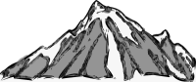– geographer instructions

You are geography specialists.

Look carefully at the map you have been given.

What does this map show you?

Which parts of the world have the highest land elevations?

The seas on the edges of continents are shallow, but where are other shallow parts of the oceans?

Where are the deepest parts of the oceans?

What do you think might cause this distribution of high and low elevations?

Part 2 – specialists working together instructions

Your team consists of seismologists, vulcanologists and geographers.

Look at the new map, showing the world divided up into what are called ‘tectonic plates’.

Tectonic plates are sections of the outermost layer of the Earth (called the lithosphere) that ‘float’ on a hotter layer beneath (called the asthenosphere). Where plates meet is called the plate boundary. Tectonic plates are moving very, very slowly; some move towards each other (converging boundaries), some move away from each other (diverging boundaries), some slide past each other (transform boundaries).

Where on the plates is the highest land?

Where on the plates is the sea shallowest?

Where on the plates is the sea deepest?

Where on the plates do most earthquakes and volcanoes happen?

- Discuss whether volcanoes or earthquakes only happen along plate boundaries.
- Discuss whether all boundaries have the same number of earthquakes and volcanoes.

Name a plate boundary where there are more earthquakes than volcanoes.

Name a plate boundary where there are more volcanoes than earthquakes.

Find New Zealand on the data maps.

How does the position of New Zealand account for its earthquakes and volcanoes?

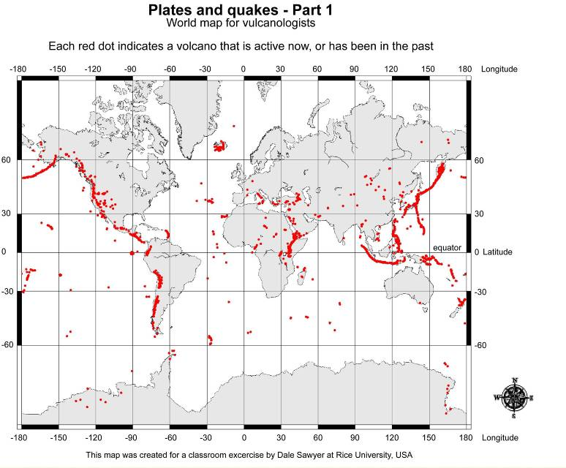
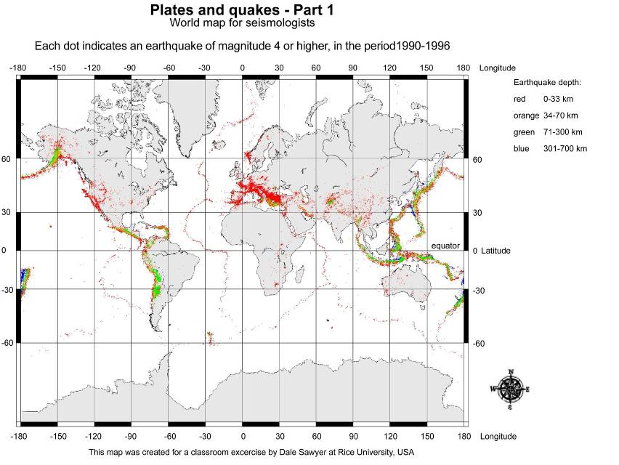

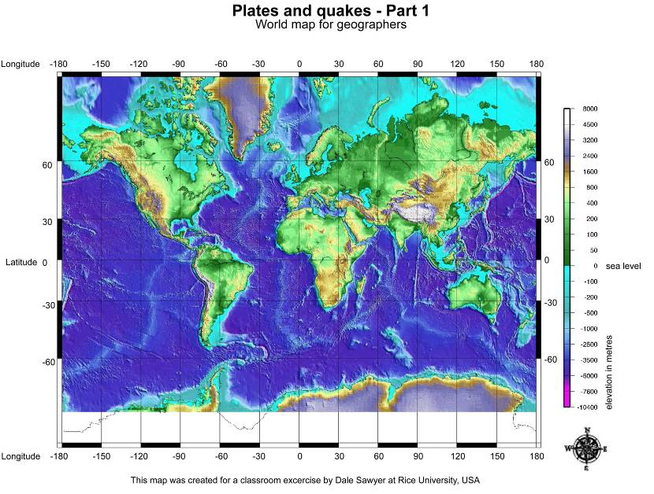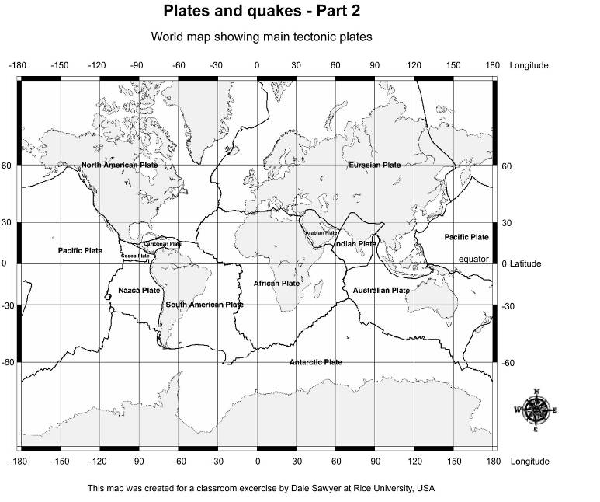

Part 3 – predicting earthquakes

Below are the locations of 5 earthquakes that occurred in 2007.

Date | Latitude | Longitude | Magnitude | Depth (km) | Region/country
14-Nov-2007 | -23 | -70 | 7.7 | 60
14-Nov-2007 | 31 | 142 | 5.0 | 27
7-Nov-2007 | 22 | 92 | 5.2 | 27
27-Oct-2007 | 38 | 21 | 5.0 | 10
27-Oct-2007 | -20 | -178 | 4.5 | 475

What to do

- Use the latitude (LAT) and longitude (LON) co-ordinates to plot the locations of the earthquakes on the seismologist’s world map (see below for instructions).

- Write the region/country in the data table.

- Check with your teacher to make sure you plotted them correctly.

- Were your predictions about the earthquake locations on tectonic plates correct?

Instruction for plotting co-ordinates using latitude and longitude

The earthquake data was collected from www.iris.edu/seismon/last30days.phtml. The IRIS site displays information something like this:

Date/time | Latitude | Longitude | Magnitude | Depth (km) | Region/country
01-Nov-2007  21:45:34 | -6.56 | 154.78 | 5.5 | 10.00 | Solomon Islands
Use this example to plot an earthquake on the seismology map:
- Latitude and longitude co-ordinates are very accurate, but when using a small map like the seismologist’s world map, you don’t need the numbers after the decimal point, so round the numbers off to the nearest whole number: Latitude -7, Longitude 155.
- Latitude is the distance north or south of the equator (which is 0º latitude). A minus sign indicates the co-ordinate is south of the equator, no sign indicates that it is north. There aren’t many numbers marked on the seismologist’s world map, so you’ll need to estimate where -7 is between 0 and -30. Make a small mark at -7 on the side of the map.
- Longitude is the distance east or west of 0º, a line that goes from the North Pole to the South Pole, through London. A minus sign tells you the number is west of 0º. No sign tells you it is east. You will need to estimate where 155 is between 150 and 180, and make a small mark.
- Use your finger (or a ruler) to track a line down from this mark until it is level with the latitude mark you made earlier. Mark this point with a clear dot – this is where the earthquake was centred.

