ACTIVITY: Birds and Planes

Activity idea

By the end of this activity, students should be able to:
- understand wing loading and work out some simple wing loads
- recognise low and high wing aspect ratios of birds and planes
- explain in a simple and general way how differences in wing size and shape affect the capabilities (such as speed, gliding and manoeuvrability) of a plane or bird.

Introduction/background notes
What you need
What to do
Student worksheet: Calculating wing loading
Student worksheet: Comparing wing aspect ratios

Introduction/background

You can tell a great deal about the function of a bird or a plane just from wing shape and size. This student activity compares wings of different flyers to determine how they might perform.

Read the articles Wing loading and Wing aspect ratio to find out about wing loading and aspect ratio. These descriptions of the wing can help us determine different types of flight capabilities of birds and planes, for example, the ability to glide, soar, speed and manoeuvre.

Wing loading looks at the relationship between mass and wing area given in kilograms per square metre of wing surface area:
- Low wing loading refers to birds and planes with comparatively low mass and large wings. They can take off and land at comparatively slow speeds and are good for gliding or slow flying. They are also more efficient because less thrust is needed to keep them flying.
- Flyers with high wing loading have comparatively large mass and smaller wings. A heavily loaded wing is more suited for higher speed flight because smaller wings offer less drag. Flight will also be smoother because the smaller wing is less affected by turbulence.

Wing aspect ratio compares the length of a wing with the width. High wing aspect ratio indicates long, narrow wings, while low aspect ratio indicates short, wide wings. Flyers with high wing aspect ratio tend to be more stable and more efficient, while flyers with low wing aspect ratio are more manoeuvrable.

What you need

- Access to or copies of the articles Wing loading and Wing aspect ratio
- Copies of the student worksheet: Calculating wing loading
- Copies of the student worksheet: Comparing wing aspect ratios
- Interactive: Wings for flight

What to do

- Read and discuss (in groups or as a class) the articles Wing loading and Wing aspect ratio.

- In pairs, have students work through the student worksheet: Calculating wing loading.

Wing loading from lowest to highest:
Albatross 1.7 kg/m²
Hang-glider 2.2 kg/m²
Sparrow 3.2 kg/m²
Godwit 7.0 kg/m²
Glider 26.7 kg/m²
Boeing 698.1 kg/m²

Students may be surprised that the albatross has the lowest wing loading when it is so much bigger than a sparrow or godwit. This helps to emphasise that wing loading is not about the flyer’s size but about the relationship between the wings and body mass. The albatross has huge wings (providing lots of lift) and a light body mass, giving it a low wing load, which helps the albatross glide at low speeds.

Something like a Boeing 747, which is very heavy and has very high wing loading, needs high speed (an engine for thrust) to fly.

- Discuss the effects of the wing flaps of the plane in the image.

Flaps on most large aircraft extend backward, increasing the size of the wing (lowering wing loading). This gives extra lift and drag allowing the plane to remain airborne at a lower speed and to descend without gaining speed. Flaps also hinge downward, increasing the camber (angle) of the wing, which increases the lift and drag of the wing as well. They are used during landing and often, at least partially, during take-off as well. During flight, the flaps are retracted for fast and efficient flying. The smaller wing reduces drag for increased speed and fuel efficiency. The increased speed produces lift so the extended wing is no longer necessary.

- Have students study the images in the student worksheet Comparing wing aspect ratios and observe and compare by sight the length to the width of each wing.
- Which bird has the highest wing aspect ratio? (Albatross)
- Which plane has the highest wing aspect ratio? (Glider)
- What does this bird and plane have in common? (They both glide, flying slowly.)

- Explain that wings of birds and planes keep them in flight. Wings are designed for specific types of flight (slow, fast) and manoeuvrability. Have students use the interactive Wings for flight to see how both bird and plane wings are designed for specific kinds of flight:
- In pairs, discuss the wing size and shape of the birds and planes on the cards. Without clicking on the cards, match a bird with a plane designed for similar kind of flight. Write down your matches.
- Now click on the cards to get the text information and read about the performance capabilities of the plane or bird. Discuss with your partner whether you still agree with your placement.
- Follow the instructions in the animation to drag and drop your matches into the best overall function box.
The best-fit pairs are:
- falcon and swing wing bomber – ability to tuck in their wings to reduce drag and increase speed
- albatross and glider – long narrow wings and light bodies enabling gliding action
- king vulture and spy plane – high aspect ratio wings enabling slow, soaring flight (similar to the glider and albatross, but their wings are slightly wider)
- hawk and Spitfire – elliptical-shaped low aspect ratio wings allow for manoeuvrability
- godwit and Airbus – capable of long-distance endurance flight at speed
- hummingbird and helicopter – ability to rotate their wings and hover.
There could be a class discussion concerning what is different about the helicopter and hummingbird. Rather than wing size and shape, their relationship is based on their ability to rotate their wings, enabling them to hover in one place. The example of the Airbus and the godwit may not be so obvious either. They both have high aspect ratio wings (long compared to width) and are designed for long-distance endurance flight at speed.
Calculating wing loading

- Order these flyers from what you think has the lowest wing load to the highest wing load.

Flyer | Wing load (lowest to highest)
- Boeing 747 (fully loaded)
- Glider (plus pilot)
- Albatross
- Godwit
- Hang-glider (plus pilot)
- Sparrow

- Now work out the actual wing loads and decide which flyer it might be from the list above. To calculate wing loading, divide the mass of the flyer by the total area of the upper surface of its wings: wing loading = body mass (kg)/wing area (m²). Each flyer uses the same measurement scale (kg and m²) to make it easy to compare them. Remember that 0.39 kg is 390 g and 0.03 kg is 30 g (1 kg = 1000 g) when matching data to flyers.

Flyer | Body mass (kg) | Wing area (m²) | Wing load
 | 0.39 | 0.055
 | 377 842.00 | 541.2
 | 9.00 | 5.3
 | 350.00 | 13.1
 | 0.03 | 0.0093
 | 106.70 | 47.24

- Which flyer has the lowest wing load? Does this match your original guess list? Why/why not?

- Which plane or bird has the most mass to lift (the highest wing load)? What else (beside wings) does this object need to become airborne?

- In this picture of a wing, the flaps are extended (compare with the inset picture where the flaps are retracted). What effect does this have on the plane? Why do planes extend their flaps to land? Why do they retract the flaps when in flight?

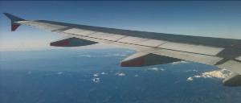
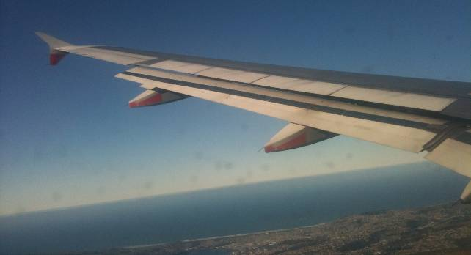
Comparing wing aspect ratios
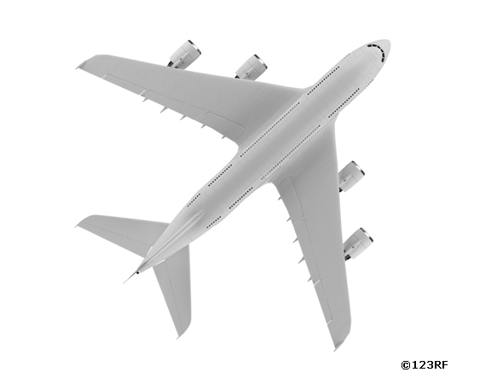 | 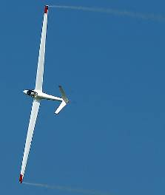 | 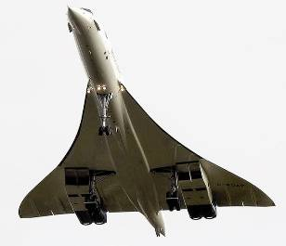
Boeing | Glider | Concorde
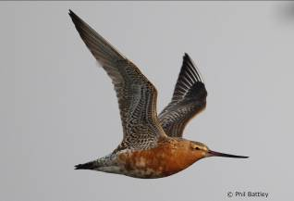 | 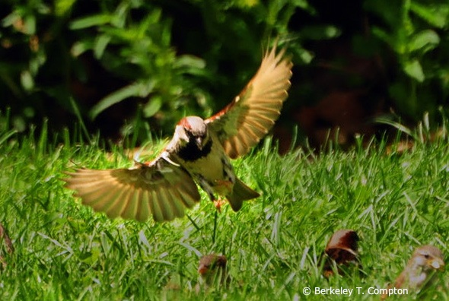 | 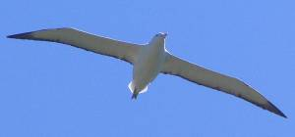
Godwit | Sparrow | Albatross

