ACTIVITY: Making a glider

Activity idea

In this activity, students handcraft a glider from balsa wood. In the process, they learn about aerofoil wing shape, glider parts and terminology. They experiment with flight using variables of wind and nose weight.

By the end of this activity, students should be able to:
- understand what an aerofoil is
- use and understand vocabulary such as wing, tailplane, fuselage, aerofoil, fin
- have some understanding of the parts of a plane and how they are needed for flight
- have some understanding of the effect of weight and the angle of attack on flight.

Introduction/background notes
What you need
What to do
Glider instructions

Introduction/background

The student activity Aerofoils and paper planes is a good precursor to this activity because it explores the aerofoil shape of the wings. Read Wings and lift to help understand angle of attack and the Bernoulli principle when exploring what gives the glider lift for flight.

In this activity, students make a balsa wood glider using instructions and a template. This is a small-sized glider. It flies well, but needs to be carefully constructed using the right equipment and materials. Accuracy is important.

Have students experiment with flying by adjusting the weight and throwing the glider into the wind slightly nose down.

What you need
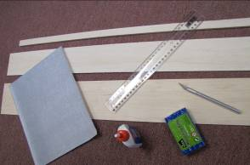
- Sharp craft knife
- Cardboard (optional)
- Fine sandpaper
- Craft glue – superglue or white PVA glue
- Modelling clay or plasticine
- Ruler
- 1.5 mm balsa wood
- 3 mm and 5 mm balsa wood (can be purchased from many model and craft shops)
- Copies of the Glider instructions
- Copies of the Glider template (this is a separate PDF file)

What to do

- Give out copies of Glider instructions and Glider template and have students build and fly a glider.

- Discuss the results.

Glider instructions

- Using the glider template, cut out the parts. (One option is to trace the template onto cardboard, cut out the cardboard glider parts and use them to trace onto the balsa wood. The cardboard glider parts can be reused.) Keep 1 mm outside the lines on the balsa wood. | 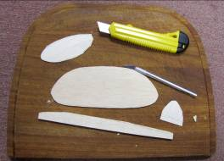
Tip:
Use the knife like a pen but don’t use just the tip – lay the knife down a little so you use more of the blade. Take care when cutting across the grain.
- Sandpaper the parts to the line.  - Round off all the edges except where the glue will be.  - Sand the wing to an aerofoil shape:  - The leading edge should be rounded off but still be about 3 mm thick.  - The trailing edge should be formed by tapering the last quarter of the wing to about 1 mm at the edge.  This takes time and careful sandpapering, but it’s worth it. | 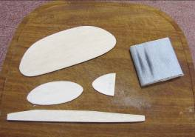
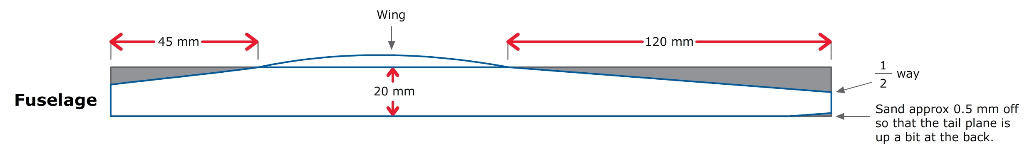

- Carefully cut the wing in half.  - Sand the cut edges on an angle so that they fit snugly together when joined, forming a dihedral angle.  - Make the dihedral angle by gluing together with one wing flat and the tip of the other raised 6 cm. |  | 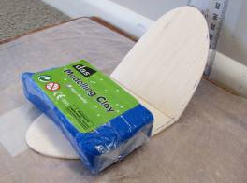
Tip:
White PVA or superglue (cyanoacrylate, medium thickness) are good glues to use. Pins can be used to hold pieces in place while glue is drying.
- Glue the fin to the top of the fuselage. (Make sure it is vertical.)

- Glue the tailplane to the bottom of the fuselage. (Make sure it is horizontal – fin and tailplane should be at right angles to each other.)

- When the wing is dry, sand the join so that it will sit flat on the fuselage. Glue on to the fuselage – make sure the wings are the same on both sides.  - Soften the weight (modelling clay) in your fingers. Place enough onto the front of the model until it balances (hangs horizontally) when supported by the wingtips.  - Throwing the glider: Hold the plane by the fuselage (under the wing position) and throw directly into the wind, aiming at a spot about 10 metres in front of you, slightly nose up.  - If the model dives, remove a little weight and try again.  - If the model drops tail then dives, add a little more weight.  - If the plane veers to one side, this may be corrected by adding a little modelling clay to one wing tip.  When flying correctly, the model can be made to turn by gently bending the fin (breathe on the fin to soften it first). |  | 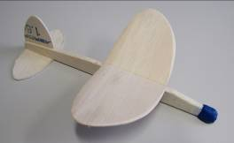
Tip:
Always throw directly into the wind!
- Other things to try:
- Add more or less modelling clay to the nose. How does it affect the flight?
- Can you make your plane fly in a circle?
- Make your plane without the aerofoil shape. Does this affect the flight?
- Buy a rubber band wind-up propeller model. Compare powered flight with unpowered.

