ACTIVITY: Aerofoils, paper planes and gliders

Activity idea

In this activity, students learn how to make an aerofoil and to make and fly paper planes. In the process, they learn about aerofoil wing shape (found on planes and birds) and experiment with flying paper planes using angle of attack and nose weight.

By the end of this activity, students should be able to:
- understand what an aerofoil is and how it works
- have some understanding of angle of attack
- have some understanding of the effects of wing shape and size, angle of attack and nose weight on flight (using paper planes).

Introduction/background notes
What you need
What to do
Aerofoil instructions

Introduction/background

Many things that fly have wings. The basic shape of wings – whether it’s a bird’s wing or a plane’s wing – is a curved shape called an aerofoil. The aerofoil shape helps birds and planes overcome weight, which is the effect of gravity pulling them down towards the Earth. The aerofoil shape helps give lift when it is moving through the air.

Read Wings and lift. The aerofoil shape of the wing causes air to move downwards following the shape. If the wing is at the right angle of attack, the air is deflected downwards both over and under the wing. This downwards action of the air has a reaction – lift on the wing. The Bernoulli principle adds that winged craft and birds achieve a certain amount of lift because air flows faster over the top of the wing and slower underneath. Fast-moving air equates to low pressure, while the slower-moving air underneath equates to high pressure. The high pressure underneath the wings gives lift, pushing the plane up through the lower air pressure.

It seems that the original explanation for lift using the Bernoulli principle is not entirely correct. Scientists have shown that the air moving above an aerofoil does not meet the air under the wing at the trailing edge at the same time as was once thought.

This was explored using two lots of different coloured smoke and moving it over an aerofoil in a wind tunnel. The smoke over the top of the wing gets to the trailing edge considerably before the air that goes under the wing. However, the air does move faster over the top of the wing so that the air pressure is lower than under the wing, which does help to create lift. Most of the lift, though, comes from the downward deflection of air off the wing (top and bottom) causing an upward reaction – lift. This comes about through the angle of attack (the angle of the wing).

An optional activity is to explore the internet to find out what people are saying about Bernoulli’s principle. Students can make up their own minds whether they think this principle (and what it actually is) fits well or not. One question to ask to stimulate discussion might be “How do planes fly upside down? Can you use the Bernoulli principle to explain this?”

This activity looks at the aerofoil shape and how it responds in moving air. Students can also make paper planes and experiment with wing shape and size, angle of attack, streamlining and weight to improve flight. Read Wing aspect ratio and Wing loading for an understanding on wing shape and size.

This activity could be followed by Making a glider, where the students can further experiment with aerofoil shape, wind, angle of attack and weight.

What you need

- A4 paper
- Text book
- Access to or copies of Wings and lift
- Paper, tape, sharp pencil, straws, cotton thread for aerofoils
- Copies of Aerofoil instructions

What to do

- Place an A4 page in the top part of a textbook so that it hanging out and down. Blow over the top of the paper – the paper will lift upwards. Ask students why they think this is.

- Have students read the article Wings and lift and ask them if they can now explain the paper lifting. (This can be explained using Newton’s 3rd law and the Bernoulli principle. The air blown over the paper is deflected downwards by the curve of the paper. The action of the air being forced down results in a reaction – lift. Also, the air pressure is lowered over the paper because the air is ‘stretched’ out over the curve, resulting in lift by the higher pressure beneath the paper.)

- Ask student to pretend the classroom is a wing. Pick one wall of the classroom to represent the bottom of the wing. The three other walls represent the top of the wing.

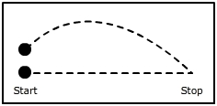
- Ask a group of 10 students to represent air molecules approaching a bird or plane wing.
- At the start, the students separate as would air molecules that encounter a solid object.
- Five students take the path of the bottom of the wing – they move along the one wall chosen to be the bottom of the wing as a group.
- The other five students travel over the top of the wing. They move faster than the other students and touch the centre of the three remaining walls, curving around until they meet the other students. They spread out as they move to demonstrate the molecules spreading out over the top of the wing. (These molecules are not so dense and therefore the air pressure is lower than the air pressure under the wing.)

- Give out copies of Aerofoil instructions and have students build an aerofoil.

- Have students make paper aeroplanes and hold a competition to see which plane goes furthest. Encourage students to make several planes and experiment to see which flies best and discuss why they think some paper planes fly further. Some suggested websites that explain how to make and fly various paper planes:
- Cobra paper airplane www.youtube.com/watch?v=X34CGZ5UZoQ&feature=player_embedded#at=16
- Origami warplane
www.youtube.com/watch?v=XzRWCenPznM&NR=1&feature=fvwp
- Nose-heavy paper airplane
www.youtube.com/watch?v=15wGj9hSL3Y&feature=relmfu
- The greatest paper airplanes www.youtube.com/watch?v=dITJuuNGJCI&feature=related
- Helpful tips to improve your throwing technique http://flightsimx.archive.amnesia.com.au/

- You may wish to incorporate fair testing into the competition. Ask the students if it’s fair for the paper plane owners to throw them. (Some people may be stronger or better throwers than others). Ask students how they could make the competition fair so that it is testing the planes and not people’s throwing ability. One idea is to make a catapult, such as the one shown, that can launch the paper planes. Remember to strengthen the notch (made to hook onto the rubber band) with sticky tape.

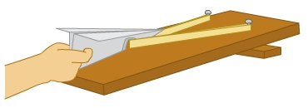
Aerofoil instructions

- To make your flying wing, you need a piece of thin paper (10 x 15 cm). Fold the paper in two, leaving an overlap of 1 cm. | 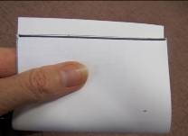
- Push the overlapping ends together. This will make one side of the folded paper curved. Tape it in place. | 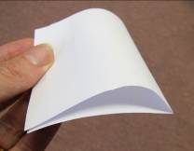
- Use a sharp pencil to pierce holes through the wing (top and bottom).  - Carefully push a drinking straw through each set of holes. | 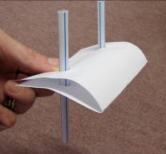
- Thread a long piece of cotton through each straw.  - Pull these tight and fix them straight between the floor and a table, so the wing can slide up and down freely. | 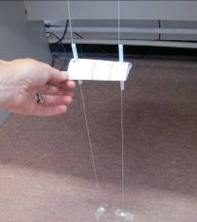
- Lift the wing up a little and aim the hairdryer straight at the folded edge. Turn it on and watch the wing lift. | 