ACTIVITY: Interpreting representations – heat pump cycle

Activity idea

In this activity, students demonstrate their ability to interpret information in scientific diagrams to develop a scientific explanation of how a heat pump works.

The activity requires students to reflect on their understanding of the science ideas represented in the diagram and consider how the representation supports them to understand these ideas through its use of scientific conventions and terms.

By the end of this activity, students should be able to:
- identify the key science ideas in a scientific diagram
- describe how the diagram supports the science ideas through its use of conventions and terms
- use information from the scientific diagram to identify the key science ideas
- write a scientific explanation of how a heat pump works using the key science ideas represented in the diagram.

Introduction/background notes
What you need
What to do
Extension idea
Student handout: How does a heat pump work?
How does a heat pump work? – answers

Introduction/background

In this task, students will use their ability to find information from a scientific diagram (visual representation) to communicate science ideas. They will also demonstrate the science capability ‘Interpret representations’ as they identify the key science ideas presented in the heat pump cycle diagram.

To develop this ability, students need to be introduced to the way information is presented in scientific diagrams. In this activity, the understanding of a cyclic process needs to be introduced, along with ways to use the annotations in the representation to identify key science ideas. Students should consider the ways scientific diagrams help communicate science ideas and think about information not included that might be important to help provide ideas.

Having identified the key science ideas, students should be supported to develop an explanation for how the basic heat pump cycle works using information about the processes that result in the cycling between liquid and gas states. To support this writing process, useful linking words provide some scaffolding for the explanation writing activity.

The article Heat pumps and energy transfer provides information on the process involved. Exploring some of the concepts in this article relating to thermal energy and heat pump design will help build students’ understanding. Although the concepts may be difficult for some students to understand, it is important to build a generalised understanding of the science processes involved as it will help students to understand how a heat pump works.

What you need

- Access to the image Relationships between states of matter
- Access to the article Heat pumps and energy transfer
- Copies of the student handout How does a heat pump work?

What to do

- Engage students in this activity by asking if anybody can explain how the heat pump in the classroom or their home works.

- Introduce the importance for scientists of being able to summarise their science ideas using a diagram with labels and annotations. Model using a simple annotated diagram of change of state such as that shown in the image Relationships between states of matter.
- Identify how the key science ideas and the labels convey information as you follow the arrows.
- Demonstrate how to record these ideas as a series of bullet points that can then be used to develop a scientific explanation.
- Model the explanation writing process using linking words such as ‘results in’, ‘leading to’ and ‘however’ to develop a scientific explanation that shows the way science ideas are linked.

- Ask students to consider how the information provided in the Relationships between states of matter diagram helps people understand the ideas through its use of scientific conventions such as terms, arrows and annotations. Also ask them to think of other information that could support people to interpret the diagram (use of colour, images).

- As a class summarise what they have learned about interpreting information in scientific diagrams so they can identify a process for interpreting information in a visual representation such as a diagram. This could be a series of steps such as:
- read the title
- read the labels
- identify the terms/words you know
- identify conventions that can help (arrows, images, colour, figures, numbers, values)
- read the annotations
- write a list of key science ideas using the information from the title, labels, annotations, and conventions.

- Hand out copies of the student How does a heat pump work? and discuss. Students can work individually or in pairs to consider information provided in the diagram and captions and answer questions 1–7.

- Discuss the four statements selected by students that link temperature and pressure ideas in the heat pump.

- Have students complete question 8. Support them to develop their own explanation of how a heat pump works using the four key ideas that the class have identified. It may be necessary to provide some sentence starters. It will also be important to identify that, as it is a cyclic process, the explanation they write might start from different points on the diagram compared to others. The article Heat pumps and energy transfer provides useful information on the processes involved. The first two sections of this article can be used to help students understand the science ideas. Some of the concepts may be difficult for some students to understand, but it is important to use the information to build a generalised understanding of the process as it can help students understand how a heat pump works.

Extension idea

Students can use the science ideas about heat pumps to develop an annotated diagram to explain how a refrigerator works.
Student handout: How does a heat pump work?

In this task, you will be using your ability to communicate in science as you find information from visual representations. You will be building skills for the science capability ‘Interpret representations’ as you identify the key science ideas presented in the heat pump cycle diagram.

You need to consider the ways this diagram helps you to understand the science ideas involved in the heat pump and also identify information that is not included that might be important in building your understanding of heat pumps.

You need to identify the key science ideas and then use these to develop an explanation for how the basic heat pump cycle works using information about the processes that result in the cycling between liquid and gas states.

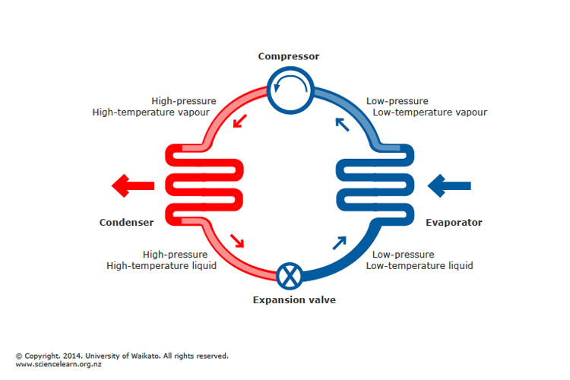

On the evaporator side of the heat pump, heat energy is taken in, converting the working fluid into gas. The condenser side liquefies the gas, releasing heat energy to the surroundings as the gas condenses back to liquid.

Read the information in the diagram and captions and then answer the following questions:

- List the words from the diagram that you know the meaning of.

- What does the diagram and caption tell you?

- What is left out?

- Are there any science ideas do you not understand in the diagram?

- How does this representation get the message across?

- Why is the diagram presented in this particular way?

- Use information from the diagram to write four statements linking heat and pressure.

- Summarise the basic heat pump cycle shown here in in two or three sentences. You should use your four statements from your answer to the question above and some of these useful linking words and phrases to provide your summary:

initially | as well as | despite | this leads to | although
as a result of | causing | but | for these reasons | however

How does a heat pump work? – answers

- List the words from the diagram that you know the meaning of.

Liquid, pressure, temperature, gas, heat energy

- What does this diagram and caption tell you?

Together, these show how a heat pump works by changing the temperature and pressure of a liquid so that it changes into a gas (vapour) using and releasing heat energy. Use of condenser and evaporator coils or fins to give increased surface area.

- What is left out?

A scale, values for temperature and pressure, idea of extent of condenser and evaporator fins to give increased surface area.

- Are there any science ideas do you not understand in the diagram?

Responses will be variable, but students’ responses should be used to guide you in teaching and learning needed to clarify the way information is presented in scientific diagrams.

- How does this representation get the message across?

Uses colour – blue = cold, red =warm. Uses circle to indicate a cycle.

- Why is the diagram presented in this particular way?

To help us understand the process by combining colour and images in a diagram.

- Use information on the diagram to write four statements linking heat and pressure.

- The expansion valve allows the liquid to lose heat and pressure.
- The condenser releases heat and causes the gas to change into a hot high-pressure liquid.
- The evaporator changes the low-pressure liquid into a low-pressure gas.
- The compressor changes the low-pressure vapour into a high-temperature, high-pressure liquid.

- Summarise the basic heat pump cycle shown here in two or three sentences.

In a heat pump, the key components are the condensing side and the evaporating side. On the evaporating side, the evaporator changes the low-pressure liquid into a low-pressure gas while keeping a low temperature. The condenser side operates at a high temperature and results in the release of heat energy leading to the condensation of the gas into a liquid while maintaining a high pressure.

