ACTIVITY: Using evidence – heat and change of state

Activity idea

In this activity, students write an explanation of how heat energy is involved in the change of state as ice changes to water and then to water vapour. The science capability ‘Use evidence’ can support students to use information from annotated diagrams to explain scientific observations.

By the end of this activity, students should be able to:
- use evidence from a diagram to explain how heat energy is involved in changes of state
- give reasons for their suggested explanation
- identify ways to check their explanation with current science ideas
- apply their understanding about changes of state to another situation.

Introduction/background notes
What you need
What to do
Student handout: Heat and change of state
Heat and change of state – answers

Introduction/background

This activity is aimed at building students’ ability to use evidence from annotated diagrams to develop an explanation for a science concept. It uses the ideas from the science capability ‘Use evidence’ to help students develop an explanation on the heat energy used in the changes of state as ice melts to form water.

Through developing responses to the questions in the activity, students should reflect on the reliability and their understanding of the evidence gained from the diagram and its annotations.

What you need

- Access to the article Hidden heat
- Copies of the student handout Heat and change of state

What to do

- Introduce students to the science ideas about the heat energies needed to change the state of a substance using the article Hidden heat. The link between calories and kilojoules will need to be introduced, as the diagram uses calories and the reading kJ for the energy added or removed.

- Discuss the ways scientists use models and annotated diagrams to represent science ideas and concepts.

- Introduce the concept that science is empirical and based on measurement and discuss how the use of measurements has been introduced in the Hidden heat resource.

- Model ways that annotations from scientific diagrams and data from investigations can be used to develop an explanation.

- Have students use these ideas as they complete the student activity. Hand out copies of the student handout Heat and change of state.

- Discuss students’ responses to the questions.
Student handout: Heat and change of state

This diagram shows the heat energies needed to convert 1 gram of ice at 0°C to its liquid and gaseous states. The unit of energy used is the calorie, which is defined as being the amount of heat energy needed to raise the temperature of 1g of water by 1°C.

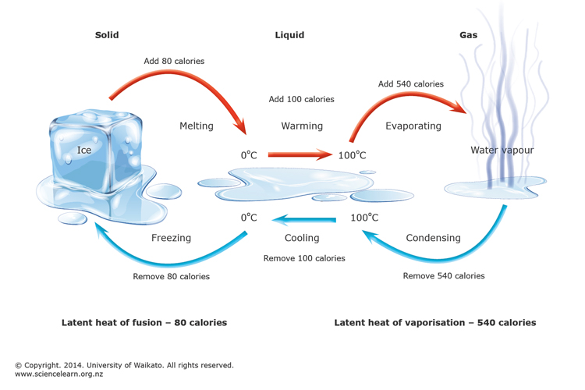

- Look at the diagram and the captions. Explain how you think heat energy is involved in changes of state.

- What makes you think this?

- How could you check your idea?

- Which other substances undergo changes of state in the same way?

- Describe a substance in which these changes of state wouldn’t occur.
Heat and change of state – answers

- Look at the diagram and captions. Explain how you think heat energy is involved in changes of state.

When 80 calories of heat energy is added to 1 g of ice that is at 0ºC, it will cause the ice to melt, changing from a solid to a liquid.

If 100 calories of heat energy is then added to the 1 g of water, it will result in the water boiling at 100ºC.

If a further 540 calories of heat energy is added, the 1 g of boiling water will evaporate, resulting in water vapour, which is a gas. Carrying out the reverse process where the same number of calories of heat energy are removed rather than added will lead to the water vapour condensing to form liquid water. With a further loss of 100 calories of heat energy as the water cools and then removal of an additional 80 calories, freezing will occur and solid ice will be formed.

(Note that this explanation does not use all the terms, such as latent heat of fusion and vaporisation.)

- What makes you think this?

Reading the information annotating the diagram as well as the caption provides these terms and statements. Have also learned that heat energy is needed to change solids to liquids and then gases.

- How could you check your idea?

Refer to a science text or online information about change of state.

- Which other substances undergo changes of state in the same way?

Metals such as tin and lead, candle wax.

- Describe a substance in which these changes of state wouldn’t occur.

Not a mixture like milk. It freezes due to the water in it, but only the water from it will evaporate to form a gas. You are left with milk solids.

