ACTIVITY: Genetics: true or false?

Activity idea

In this activity, students use an interactive or paper-based graphic organiser to explore common alternative conceptions about genetics. This activity can be done individually, in pairs or as a whole class.

By the end of this activity, students should be able to:
- better explain some key genetics terms including ‘DNA’, ‘gene’ and ‘chromosome’
- describe the basic processes by which genetic information is passed from 1 generation to the next.

Introduction/background notes
What you need
What to do
Extension ideas
List of statements
Graphic organiser worksheet
Teacher answer sheet

Introduction/background

Genetics is a complex topic. Many students form their own ideas about key aspects such as DNA and heredity based on their own experiences and observations as well as exposure to the media. Before carrying out this activity with your class it is recommended that you read the teacher resource Alternative conceptions about genetics, which highlights some of the more common misunderstandings.

This activity can be used at the start of a genetics unit to assess prior knowledge or at the end as an assessment activity.

What you need

- Access to the interactive graphic organiser or the printed list of statements and graphic organiser worksheet.
- Optional: Access to the articles DNA, chromosomes and gene expression, Genotype and phenotype, Meiosis, inheritance and variation and Role of proteins in the body.

What to do

- Allow the students sufficient time to complete the interactive graphic organiser, either individually or in small groups on a computer. This can also be a whole class activity via an interactive whiteboard (IWB). If using an IWB, encourage students to come up and move the statement cards to the appropriate box and to move a statement card if they do not agree with its position. If the internet is unavailable, use the paper-based version. Provide the list of statements (cut up into small cards) and ask students to place them in the appropriate box on the graphic organiser worksheet.

- Invite students to share their ideas with the class. Address any alternative conceptions that arise.

- If appropriate, allow students time to research any statements they are unsure about. This research could be web-based or using the print-outs of the articles DNA, chromosomes and gene expression, Genotype and phenotype, Meiosis, inheritance and variation and Role of proteins in the body.

Extension ideas

- If you have an interactive whiteboard with voting capability, you could set this up as an anonymous voting activity as a useful way to gauge the understanding of the class.
- Ask students to rewrite the false statements so that they read true. Discuss as a class.

List of statements

DNA is found inside the cell nucleus | You have the same set of genes as your neighbour
DNA is found in all our cells | Chromosomes can be seen without a microscope
The DNA in your skin cells is different to the DNA in your liver cells | Human cells contain 46 chromosomes
Genes are made of DNA | Brothers and sisters have identical DNA
Genes code directly for our traits | Genes pass from 1 generation to the next via chromosomes
1 gene is responsible for 1 trait | Your phenotype can change throughout your life

Graphic organiser worksheet

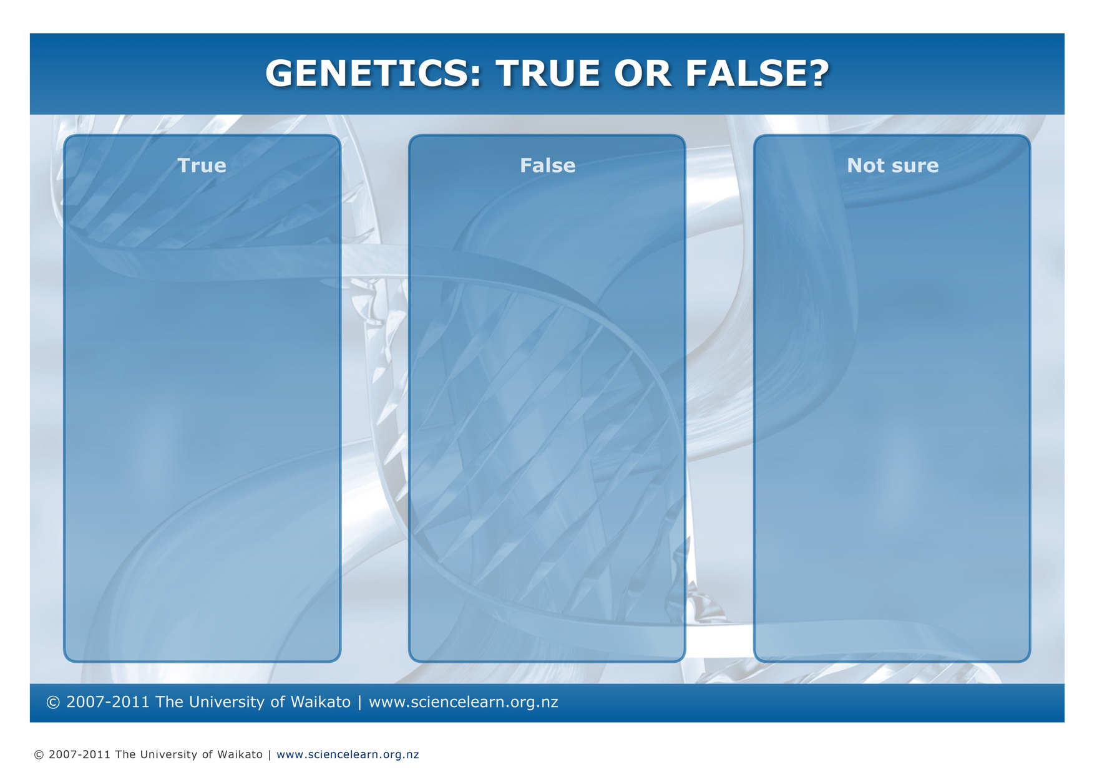

Teacher answer sheet

Statement | True or false? | More information
DNA is found inside the cell nucleus | T | Most of your DNA is found in the cell nucleus. Mitochondria (types of cell organelle) also have a small amount of their own DNA.
DNA is found in all our cells | T | All human cells contain DNA (except for mature red blood cells). If students consider the statement is false, they are technically correct but be aware of the common misunderstanding that DNA is only found in specific cells such as the brain or reproductive system.
The DNA in your skin cells is different to the DNA in your liver cells | F | Every cell in your body (other than gametes) contains the same DNA and consequently the same genes. However, not every gene is expressed in every cell.
Genes are made of DNA | T | A gene is a segment of a DNA molecule (a sequence of bases).
Genes code directly for our traits | F | Indirectly, they do, but more specifically, genes code for proteins whose functions are responsible for our traits.
1 gene is responsible for 1 trait | F | While there are a few traits that are due to a single gene (for example, dimples and cleft chin), most traits are complex and are the result of the interactions between the protein products of several genes.
You have the same set of genes as your neighbour | T | All humans have almost exactly the same genes, in the same order, along our chromosomes. Our uniqueness is a result of the different combinations of alleles that we inherit from our parents.
Chromosomes can be seen without a microscope | F | During cell division, chromosomes coil up tightly into X shapes and are more easily visible under a microscope.
Human cells contain 46 chromosomes | T | This is true except for gametes (egg and sperm cells), which contain 23 chromosomes. It is possible to accept ‘false’ as an answer if this additional information is provided.
Brothers and sisters have identical DNA | F | Except for identical twins, we all have unique DNA.
Genes pass from 1 generation to the next via chromosomes | T | Each egg and sperm cell contains 23 chromosomes (which contain genes), and these combine to form a zygote in an individual in the next generation.
Your phenotype can change throughout your life | T | Your phenotype is a result of the interaction between your genotype and your environment and is therefore always changing in response to environmental factors including sunlight, diet and age.

