ACTIVITY: Using rongoā Māori

Activity idea

In this activity, students learn about some of the plants used in rongoā Māori through a silent card game. Rongoā is the traditional Māori healing system, a holistic practice that often includes the use of medicinal properties produced from New Zealand native plants.

By the end of this activity, students should be able to:
- explain what rongoā Māori is
- name some native plants in New Zealand that are used for rongoā Māori
- name some medical problems that native plants can be used for
- name some medical uses for some of the native plants

Introduction/background
What you need
What to do
Native plants
Medical problems and uses

Introduction/background

Although most of our science knowledge today to do with fighting infection has come through western culture, other cultures, such as Māori culture, have long been aware of plants that have medicinal properties that fight or prevent infection.

Rongoā is the traditional Māori healing system. Rongoā is a holistic practice that often includes the use of medicinal properties produced from New Zealand native plants.

This activity looks at some common native plants that are used for rongoā. Students learn about some of the plants’ medical uses and some of the diseases and problems that can be treated with various parts of the plants. The students then play a silent card game that involves matching some of the medical problems and uses to the appropriate native plant.

What you need

- Access to the article Rongoā Māori
- One set of 6 native plants cards per group
- One set of medical problems and uses cards per group

What to do

- Divide the class into groups of 3–4

- As a class or in groups, read and discuss the article Rongoā Māori.

- Give each group a set of the 6 native plants cards (face down) and a set of the medical problems and uses cards (face down).

- Explain the task:
- On the ‘go’ command, students can flip over cards.
- They need to match the medical problems and uses cards with the appropriate native plant (e.g. ulcers, sore throats and a germicide would go with the pūriri tree.).
- They may use the article Rongoā Māori to help them.
- They have a limited time to complete the task (depends on age/capability of students).
- They are not allowed to speak during the task. This is a silent card game. They may gesticulate and communicate but without talking.
Native plants
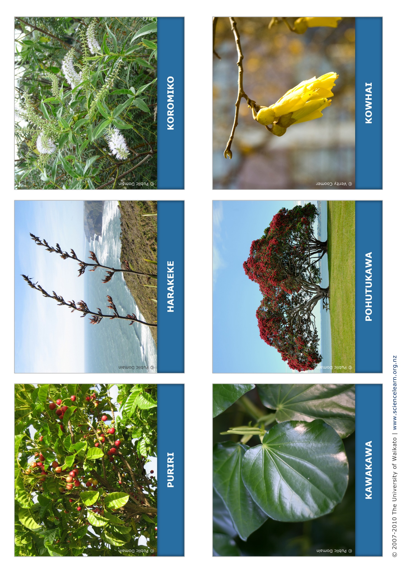

Medical problems and uses

