ACTIVITY: Literacy in immunology

Activity idea

In this activity, students present their science knowledge on fighting infection in a form of literacy.

By the end of this activity, students should be able to:
- draw a mind map showing the interrelatedness and function of some the immune cells
- write a poem about immune cells and their function
- write a fictional story using scientific knowledge of the immune system and immune response.

Introduction/background notes
What you need
What to do
Mind map examples
Poem examples
Short story examples

Introduction/background

Literacy is an important part of the curriculum. Students need to have good reading and writing skills to be able to adequately address other areas of the curriculum such as science. In this activity, students use the medium of literacy to further explore and consolidate ideas about the immune system and immune response.

Some mind maps, poems and stories from year 5–6 students are included as examples.

Many of the other teaching and learning activities in this context should be covered first, particularly those specifically related to the immune system (The wars within and Drama with microbes). The ideas in this activity are a consolidation of learning and could be used as separate activities following some of the other learning (for example, mind maps could follow teaching on the immune system).

What you need

- Large sheets of paper for mind mapping
- Computers/paper for writing poems and stories
- Examples of mind maps, poems and short stories from year 5 and 6 students

What to do

- Show students examples of mind maps, poems and from year 5 and 6 students.

- Use student examples to teach writing techniques:
- Discuss terminology and use of specific scientific language (for example, macrophage, T helper cell etc).
- Discuss figures of speech and how they are used. Particularly note the use of personification (giving human qualities to something that is not human). This is also called anthropomorphism (attributing human characteristics to non-human things). This figure of speech helps us to relate to the cells in the immune system, but we should remember they are not human and don’t really ‘think’ or behave in the same way we would.
- The use of similes and metaphors also help us to understand what is happening with the cells. Similes make a comparison using the word ‘as’ or ‘like’ (“I swell like the sea”). A metaphor makes a direct comparison (“I’m a huge blanket that wraps over you”)..

- After observing the example mind maps, students design and draw their own mind map depicting the immune system, showing the various cells, ideas about them including their function and relatedness to others. The maps could be colour-coded to show differences between groups of cells (and viruses etc) as in the examples – immune cells, blood cells, pathogens etc.

- Read the example poems written by year 5 and 6 students. Students write their poems from the view of being a cell or microorganism in the immune system. Collate into a book of poems for all to read.

- Read the example short stories to students and discuss narrative writing (your expectation for short stories, use of figures of speech etc). Talk about how the science is embedded in the narrative. Students should try to depict an accurate portrayal of the science, using scientific terminology, even though the story is fictional and anthropomorphism might be used. Students write narratives and make into a book.

Mind map examples
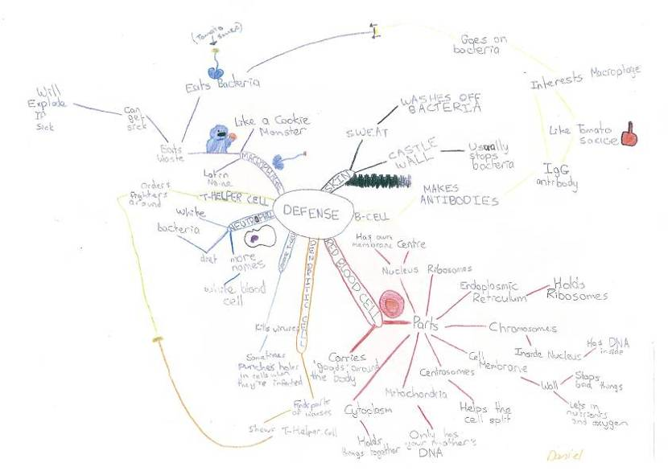
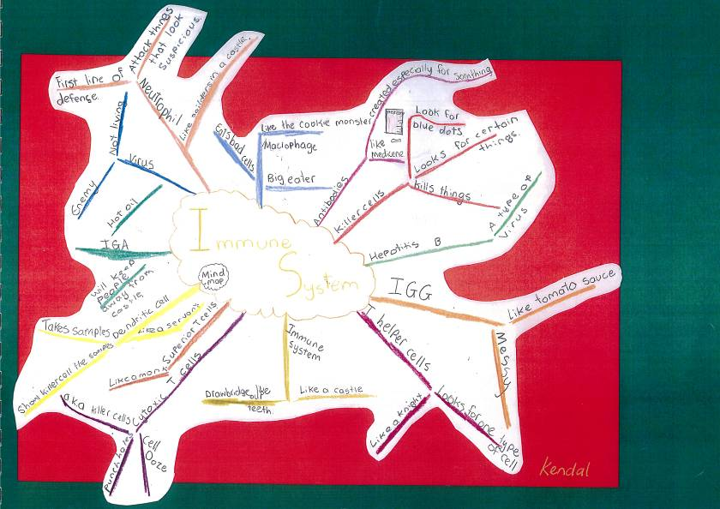
Poem examples

Macrophage
I’ll happily eat any leftovers,
I’ll be happy to eat any time,
My favourite sauce is IgG,
I’m big and round and pudgy,
The body is my place,
It’s an all you can eat café,
What a lovely life! Hooray!

I gobble it all no matter what it is,
I am here,
No need to fear,
I eat everything dead,
No need to dread,
That’s me the macrophage.
I’ll clean up after a fight,
A yummy neutrophil,
Or an erythrocyte!

Immune system
Neutrophils are like foot soldiers,
They attack in crowds and die,
Like men at war.
Then B cells come in and shoot,
Antibodies at the attacker,
It’s the macrophage’s turn to eat the neutrophils,
Who fought bravely and did their duty.

Dendritic cell
A murmur in the background,
Receiving all the attention,
Collecting offering then collecting again,
Brewing potions using simple rumours,
and gossip,
Then spilling them on public roads.

Rushing around like a kid in snowball tag,
Running a 100 metre sprint,
A nosy police officer,
Finds the latest news first,
News reporter,
The big cheese,
Celebrities,
Dendritic cell.

B cell
Brewing potions efficiently,
Referring to the immunity cookbook,
My time in the kitchen never ends.

As protecting as a shield,
When introduced to enemies,
I stop them coming again,
My concoctions act like repellent,
I keep the castle safe.
Short story examples

Written by year 5 & 6 Students.

THE DOWNFALL
(Extract from SHRUNK!!)

I was somewhere in the bloodstream. Inside the endless tube there where lots of little ovals zooming up and down, “Professor, what are those?,” I asked. “They are red blood cells, they zoom up and down the blood stream, carrying oxygen from one place to another.”, the Professor answered. “Prof, state our co-ordinates” Harry ordered. “We are in the 567gg6422136ggdl13434686 blood stream Sir,” the Prof rapidly said. “Good, now James follow me and be quiet”. For a while we walked (well swam) through the blood stream. Suddenly we saw a huge shadow, something was coming around the corner! “Dr what is that?” I wimpered. “That is neutrophil, they are the first line of defense, they come up to you, sniff you and destroy you!”. “De-destroy you?” I cried. “STAND BACK!!!!!” Harry boomed at the neutrophil, he turned to us, “I can handle this”. Harry jumped onto the neutrophil it wiggled, jumped and ate Harry! I fainted. When I woke I was riding on the back of a GIANT cell. “This is a dendritic cell,” said the Professor, “it brings all it finds to the helper T cell” helper T what?” My speech was cut short as an amazing sight met my eyes. A huge line of dendrites was slowly moving towards a colossal figure of a helper T cell, it was looking at all the things that the dends had bought him. In the distance I saw Harry riding another dendy, the T helper cell looked over him. “MACROPHAGE!!!”, it thundered. Like a cat another huge cell slid over, it took one look at Harry and gobbled him up!!

I ran for it.
YAAAAAAAAAAAAAAAAAAAAAAAAAAAAAAAAAAAAAAAAAAAAAAAAAAAAAAAAAAAAAAAAAAAAAAAAAAAAAAAAAAAHH

I was zooming around corners like a terrified dog, behind me I saw some jaguar like creatures zipping after me. “Cytotoxic T cells”, said the professor. Suddenly the little computer turned into a quick looking scooter, I pounced on it. I looked around the corner, A CUT!! I can escape!! I crashed through it, I found myself on the knee of a person. Suddenly the computer turned into a growth gun! I pointed it at myself and pulled the trigger. I grew and grew and grew and grew and grew and grew and grew and GREW!! I grew until I was back to normal size. The Professor burst into the room. “Where’s Harry?”
“UM...”. I said as I ran out the door “Macrophaged”

NARRATIVE OF THE HUMAN BODY

Something bad was going to happen. The moment I saw him, I knew something bad was going to happen. And guess what? Something did. It all started on a warm summer day. The clouds were like flocks of sheep running in the sky. A beautiful day, no-one expected anything bad to happen to happen, bud some days are just too perfect, so perfect that something bad just had to happen. And I knew that something would when I heard a mad scientist was coming to school! Not just any scientist, a ‘mad’ scientist. We then walked down to the hall nervously where the scientist was waiting. We sat down. The scientist did not waste any time. “Now, today I’m going to show you my incredible shrinking ray! I eyed him up and down looking at his tall spiky hair, his stained ivory lab coat, and a disgusting looking cut on his arm. “He looks as crazy as he sounds!” I whispered to my best friend Michael. Michael chuckled. “Now, you may think I’m crazy, but let your eyes be amazed at my wonderful invention ... the shrinking ray!” He then pulled a back a black cover revealing ... a box! Everyone burst out laughing. “Uhh, pardon me.” Then he opened the box and pulled out something that looked like a water pistol. “Now, I will shrink that box into the size of a ping-pong ball!” He turned a switch clockwise, and then pulled a trigger, sending a green ray of light towards the box and shrinking it into well, the size of a ping-pong ball! Everyone was amazed especially Michael and I. “Again, Again!” everyone shouted. He placed another box in the middle of the floor. He did the same thing but turned the switch further this time. But just as he was about to shoot, he coughed and sent a green ray heading for Michael and I! We tried to dive but it was too late, we were shrinking! We ended up in mid air – heading for the mad scientists disgusting cut in his arm! We braced ourselves as we cascaded down into his cut and into his body! “What happened?” Michael asked. “I don’t know.” Being an expert on the body Michael realised they were in the scientists arm!

“Umm, Michael, you’re an expert on the body, what’s heading for us?”
“That seems to be a neutrophil.”
“And ... what do they do?”
“They eat you. Run!!!”
Wait! What is this stuff” I can’t run in it.”
“Oh, it’s blood”
“Blood? Yuck! Anyway, in that case, swim!” the neutrophils were nearly upon us so we had to dodge them. We swam and swam until they were out of site.
“Phew, that was close!”
“Think again! That’s a macrophage heading for us!”
“Let me guess, they eat you too?”
“Yeah, you’re right. We need to find somewhere to hide!”
“Why?”
“Well first so the macrophage can’t eat us and second so the T helper cells can’t find us and then report to the cytotoxic T cells which will come and kill us if they happen to find out that we’re here.”
“Oh, right. Should we hide behind that blobby thing”.
Michael had a confused look on his face. “Hang on! This is the T helper cell!
We need to get away!”
“Right behind yah!” All of a sudden we felt a massive surge of blood hit us and send us flying back towards the cut!
“Look the scientist is squeezing us out!”
“Let’s hope he does it soon, I’m pretty sure those are cytotoxic T cells heading for us!”
“You’re right! Try and head for the cut!” So we swarm with all our might and managed to squeeze out through the cut! We then landed in the palm of the scientists hands. He then switched his ray to reverse and sent a purple wave flying at us. We then felt a weird shaking feeling in our body as we grew to our normal size again! “Wow! that was amazing!”
“Yeah, and messy, you smell and look awful!”
“I could say the same thing about you!”
“Yes!, I can’t believe it! My wonderful invention actually worked!” The scientist shouted.
“Right, I’m going to call home, I really need a shower!”
“Couldn’t agree more!” Michael answered cheekily.

