ACTIVITY: Inside a cell

Activity idea

In this activity, students learn about the contents of a cell. They explore some of the main organelles within a cell using the analogy of a school, an online interactive and/or by making something edible.

By the end of this activity, students should be able to:
- name some of the organelles within a cell
- explain some of the functions of some of the organelles.

Introduction/background notes
What you need
What to do

Introduction/background

This activity follows on from Introduction to cells and precedes Introduction to DNA. Recap: living things are made up of cells; there are approximately ~10¹³ cells in the human body; we have cells with different jobs, such as muscle cells, skin cells or brain cells.

If we can look at different cells, we see they have different shapes and may have different structures inside the cells. These intracellular structures are called organelles. To help explain the organelles, use an analogy of the school.

What you need

- Whiteboard or large piece of paper (for drawing/showing school analogy)
- Access to an interactive description of organelles
- Access to the Cells in 3D – slide show
- 3D glasses – sets of 10 from AliExpress cost less than $3.00.
- Ingredients for making a cell model – see step 4.

What to do

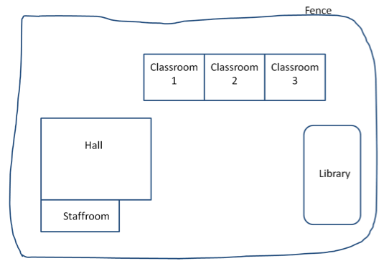
- Display a basic map of a school where everyone can see it and explain the school/cell analogy:

Imagine the school was having a gala and the teachers decided all the baking would be done at school. All the ingredients were at school and Class 1 was going to make sponge cake, Class 2 was to make muffins and Class 3 was to make biscuits. Everything was ready, but no-one had a recipe. Where would the students find a recipe? (Unfortunately, this school had no internet access!)

The library! Class 1 worked this out first and a student rushed to the library, found there was only one recipe book so took it back to her classroom and they started making sponge cake, but that meant that no-one in Class 2 or Class 3 could see their recipe and therefore couldn’t make any muffins or biscuits for the gala.

This could have been avoided if the library teacher had done something special – which is often done with big expensive books (dictionaries, atlases). The recipe book could have been in the Reference section so that it is not allowed to leave the library. The student from Class 1 could have found the recipe for sponge cakes and written down the recipe, then left the recipe book in the library for the other classes to do the same.

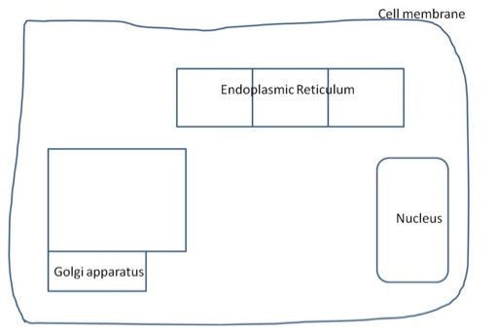
This is similar to how a cell manages to keep the instructions for all the different jobs it might have to do. Rather than a recipe book in a library, the cell has DNA (recipe book) that stays inside the nucleus. The DNA instructions for the cell are transcribed (just like writing out the recipe) and then those instructions are taken out of the nucleus to the endoplasmic reticulum (classrooms) where ribosomes (students) follow the instructions to put units together (translate) into compounds the cell needs called proteins (muffins and cakes). Before the school can sell baking at the gala, it needs to be packaged up (put on plates, covered in cling wrap, labelled). The cell also packages up some proteins in Golgi apparatus.

Many schools are surrounded by a fence. The fence prevents large things from entering the school (animals, cars, people) or the school contents escaping (!) but small things could pass in/out between the fence poles (homework, food, pencils). The cell membrane works in the same way – large structures or other cells can’t get in easily, but small essential molecules (food and oxygen) are able to pass into the cell. Another important part of the cell is the powerhouse to generate energy. In older schools, there is often a boiler room, which is the source for the heat to the school. Mitochondria in the cell provide the energy for the cell to survive.

Lots of rubbish is made in a school, and it has to be removed constantly so it doesn’t pile up and become dangerous or stinky! Cells also make waste that has to be removed from the cell. Just as school children put rubbish into special containers (bins), the cell puts waste into containment areas called vacuoles. These are able to move through the cell, collecting waste and eventually move to the cell membrane and throw the waste outside of the cell – just as if the rubbish was being put outside the school gate for collection.

- To find out more about organelles, students can view the interactive at www.cellsalive.com/cells/cell_model.htm.

- Students could view 3D colour images of cells on the Cells in 3D – slide show using 3D glasses.

Get the students to draw the inside parts of cells themselves using crayons – use the interactive at www.cellsalive.com/cells/cell_model.htm to help students draw the inside parts of cells.

- Student groups could make their own edible ‘cell’ so that they can easily visualise how it is made up. Students could make cell pizzas beginning with the base and adding ingredients that represent organelles. See www.ehow.com/how_2241417_build-3d-models-animal-plant.html for another cell model designed to be eaten.

