ACTIVITY: Develop a classification system

Activity idea

In this activity, students work in small groups and come up with their own classification system for a number of marine organisms.

By the end of this activity, students should be able to:
- explain what general classification is and why it’s important
- experience devising and revising their own classification system
- better understand why scientists do not always agree and why species may be reclassified as new information comes to light.

Introduction/background notes
What you need
What to do
Discussion questions
Possible variations
Image cards
Organism information

Introduction/background

Classification is an important tool used by scientists to show how organisms are related to each other. It’s also used to group organisms by their characteristics, but this can be difficult for some marine organisms. Scientific classification involves grouping organisms into a series of hierarchical categories: kingdom, phylum, class, order, family, genus and species. These categories were first developed by Carl Linnaeus in the 18th century and have remained in common use ever since. However, there is often significant debate amongst scientists about the groupings of organisms within these categories.

There are literally millions of different organisms on Earth. Classification makes it easier to study organisms as each has their own unique name that is understood internationally. Classification also helps us understand the relationships between different organisms.

When scientists classify organisms, they may use a combination of:
- characteristics that are visible to the naked eye
- characteristics that can only be seen under a microscope
- DNA analysis
- how the organism grows and develops as well as other life processes
- behaviour
- evolutionary history.

What you need

- Set of image cards per group
- Organism information per group
- Pen and paper

What to do

- Begin by discussing what the students know about classification. Can they think of any examples of how we classify everyday objects (by colour, size, purpose)? Can the students come up with any science-based classification terms, for example, kingdom or phylum; mammal or reptile? Useful prompts for the discussion:
- Briefly discuss the Linnean classification system and give some examples.
- Why do you think classification is important?
- What evidence do you think scientists look for when deciding how to classify an organism?
- What do you think happens when scientists disagree?

- Hand out a set of image cards to each group and a copy of the organism information. (The images are of organisms profiled within the Life in the Sea context. Students can refer back to the articles if they have questions about individual characteristics.)

- Working in small groups (3–4), each group needs to group the organisms shown on the image cards using the organism information provided. There is no right or wrong way to do this but the group must agree.

- When the group has finished classifying the organisms, they need to name each group and record the common characteristics of each group (the selection criteria they used to decide which organism can be a member of that group).

- Have each group share with the class how they grouped you organisms and the reasons behind their classification system.

Discussion questions

- Were there any organisms that you didn’t know? How did this affect the way you grouped them? How do you think scientists go about classifying new/unknown species?
- After listening to how the other groups classified the organisms, would you make any changes to your system? (If time permits offer each group the opportunity to revise their system and selection criteria).

Possible variations

Variation 1

- Remove 3–5 images before handing out the image set. After a group has completed step 4, give them the remaining cards and ask them to use their selection criteria to fit these new images into their chosen groups.
- Discussion question: Did the new organisms fit into your classification system? Did you have to make any changes to your selection criteria?

Variation 2

- After step 5, explain to the students that the next job is to divide their groups further. For example an original group of ‘consumers’ can be further divided into herbivores and carnivores. Once again, students should record their selection criteria.

Variation 3

- Either as an introductory or extension activity, ask the groups to classify the organisms by one or more of these suggestions:
  - Living or non-living
  - Animals or plants (or by kingdom)
  - Role in the marine food web
  - Vertebrate or invertebrate
  - Where they live

Image cards
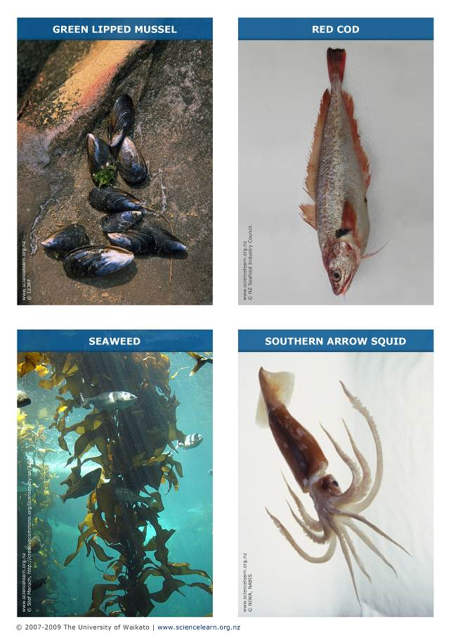
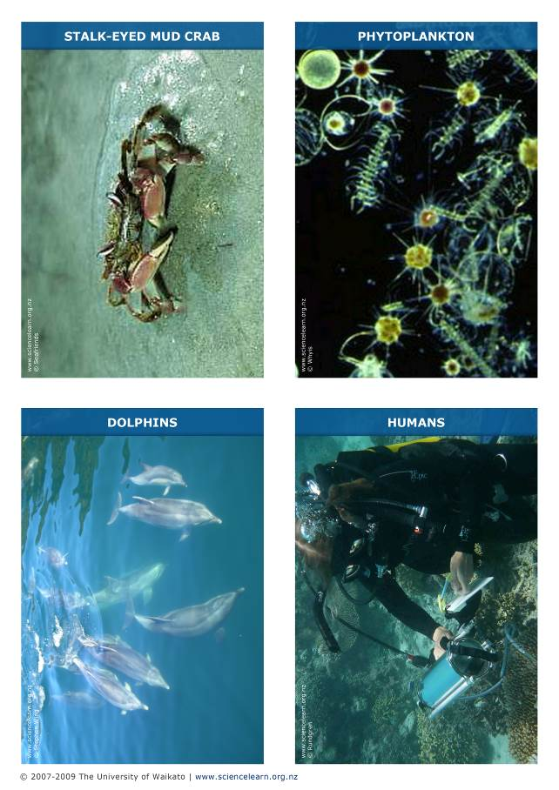
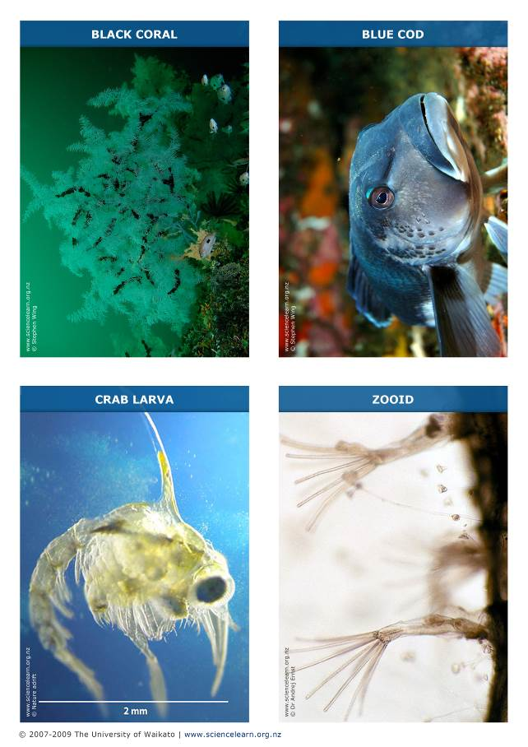
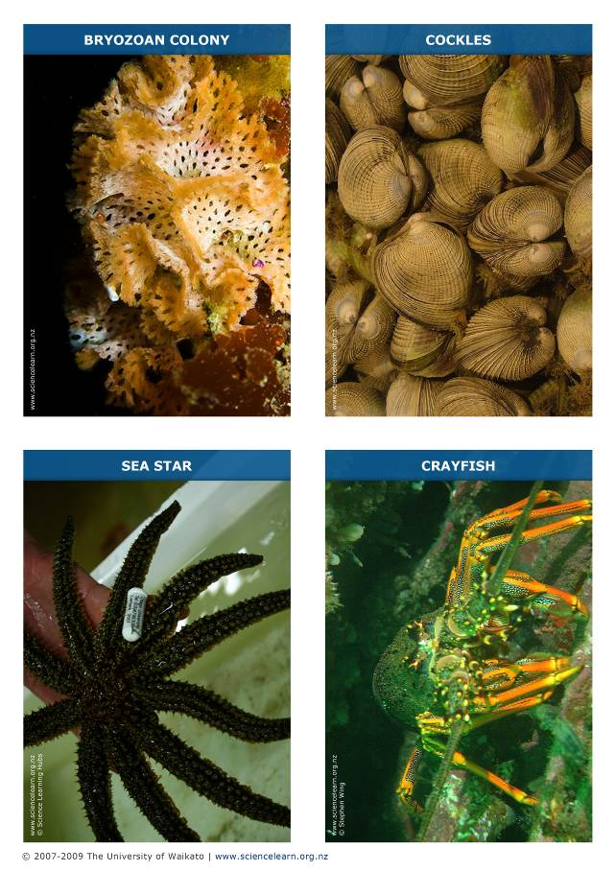
Organism information

Organism | Basic information
Green lipped mussel | Mollusc, lives in the intertidal zone, filter feeder, normally clumps together in groups, eaten by humans and sea stars.
Red cod | Normally found at depths of 100–300 metres, feeds on crabs, shrimps and small fish, adults about 40–70cm in length.
Seaweed | Type of algae, primary producer, grows in clusters with other seaweeds, provides shelter for small marine organisms.
Southern arrow squid | Mollusc, mostly nocturnal, feeds on crabs, small fish and sometimes other squid, eaten by birds and large fish, food source for humans.
Stalk-eyed mud crab | Habitat is low-tide zone, cannot survive out of the water for more than 8 hours. Popular food source for many fish, stingrays and seabirds.
Phytoplankton | Primary producers, microscopic, single-celled organisms, float freely in the ocean, eaten by zooplankton.
Dolphin | Vertebrate, mammal, lives in the water, feeds on fish.
Human | Vertebrate, mammal, lives on land, eats a number of marine animals.
Black coral | Tree-like coral, found in Fiordland, made up of colonies of identical organisms like sea anemones, feeds mostly on phytoplankton.
Blue cod | Marine fish, adults up to 60cm long, can live up to 150m below the surface, popular food for humans.
Crab larva | Part of the zooplankton, crustacean, feeds on phytoplankton.
Zooid | Bryozoan colonies are made up of zooids, makes a calcium carbonate skeleton, feeds on phytoplankton and dissolved plant matter in the water.
Bryozoan colony | Phylum: Bryozoa, made up of hundreds or thousands of zooids.
Cockle | Mollusc, filter feeder, feeds on phytoplankton, lives in estuaries.
Sea star | Echinoderm, consumer, eats mussels.
Crayfish | Crustacean, breathes through gills, popular food for humans, feeds on crabs and small marine organisms.

