ACTIVITY: Pollination pairs

Activity idea

In this activity, students match native flowers with their pollinators, basing predictions on the main characteristics of flowers pollinated by wind, insects or birds.

By the end of this activity, students should be able to:
- recognise the characteristics of flowers pollinated by wind, insects or birds
- understand how the structure of a flower is related to attracting pollinators
- use scientific terminology of flower parts.

Introduction/background
What you need
What to do
Extension ideas
Flower cards
Pollinator cards
Teacher answer sheet

Introduction/background

Pollen cannot move from male to female flower parts on its own, so plants rely on other agents for pollination. Pollinators can be biotic, such as insects or birds, or abiotic, such as wind. Plants are normally pollinated either by biotic or abiotic agents, though sometimes by both. Flowers use a variety of strategies to attract biotic pollinators or to ensure abiotic pollination. Make sure your students are familiar with the role of flowers in pollination outlined in the articles Flower parts and Attracting pollinators.

It is often possible to look at the features of a flower and predict what type of agent pollinates it. However, such predictions really need to be tested by observations of the flowers and their pollinators, as there are so many specialised features to take into account. Early botanists looking at New Zealand native plants thought that few of them had the characteristics of bird-pollinated flowers. When scientists started to actually observe the pollinators that visited flowers, they realised that many more are bird-pollinated than was predicted.

You can use some general characteristics to predict pollinators, but these are not rules. Insect-pollinated flowers are hardest to characterise as there are so many different types of insect.

Wind-pollinated flowers
- Huge amounts of pollen.
- Often have no petals.
- Often have many small flowers packed onto a flower spike.
- Large stigmas and exposed anthers.
- No scent or nectar.

Insect-pollinated flowers
- Often white, green or pale-coloured petals but can also be brightly coloured.
- Sometimes have obvious guide marks.
- Have nectar.
- Can have strong scent, especially when pollinated by night-flying insects.
- Anthers and stigmas arranged to help pollen transfer by specific flying or crawling insects.

Bird-pollinated flowers
- Often brightly coloured petals (red, yellow, orange).
- No scent (birds do not have a strong sense of smell).
- Lots of nectar as a reward.
- Anthers and stigmas arranged to help pollen transfer by specific nectar-eating birds.

What you need

- One set of flower cards and one set of pollinator cards (keep separate). If working in small groups, you will need one set of each per group. Print the cards directly onto thin cardboard and cut out or print onto paper that is then glued to cardboard. It will help if each set has a different coloured backing card.

What to do

- Discuss the characteristics of flowers pollinated by wind, insects or birds with your students.

- Shuffle the flower cards and lay them, with pictures showing, in front of the class (or arrange on a whiteboard). Place the pollinator cards in a separate group.

- Get one student to choose a flower and describe it to the rest of the class. The same or a different student should then decide what pollinates that flower and place the relevant pollinator card next to the flower. You could discuss this as a class to agree on the pollinator. (There is a teacher answer sheet to help you.) Repeat until all the flowers are matched with their pollinators.

- When students are familiar with the flower and pollinator pairs, use the same cards to play a memory pairs game to help cement the knowledge. You could play the game with the class divided into a few groups from which ‘card choosers’ are selected, or you could have a number of small groups each with their own sets of cards:
- Shuffle the flower cards and place them in a group, pictures facing down.
- Shuffle the pollinator cards and place them in an adjacent group, words facing down.
- A student turns over a flower card then a pollinator card. If it is the correct pollinator for that flower, the cards can be picked up and kept by the finder (or their small group). If it is not the correct pair, they should be turned back face down. It is important that, when the cards are turned over they are not moved within the arrangement, as students will need to remember the positions of cards.
- When all the pairs have been found, the winner is the group or individual with the most pairs.

Extension ideas

Look at flowers around the school grounds and predict what pollinates them. Test these predictions – record the animal pollinators that visit different flowers in the school grounds. Divide the class into groups to watch different flowers for periods throughout a day or more. Set up data sheets so that, at the top, students can record the flower and what it looks like, the time and weather. The rest of the sheet can be used to record the different animals that visit in a set time (or absence of animals if the flower is wind pollinated). You could extend this to include the actual number of visits by different animals and how long they stayed. This will enable you not only to list which animals visit but to record which species seem to be doing the most pollination. The numbers of bird-pollinated flowers likely on school grounds are limited, but could well include harakeke and kōwhai for a short time in spring. If you have these flowers, record which birds visit and discuss the characteristics that make them suitable pollinators.

Discuss possible characteristics of flowers pollinated by water, bats or geckos. Follow this up with some research on actual flowers pollinated by these agents.

Flower cards

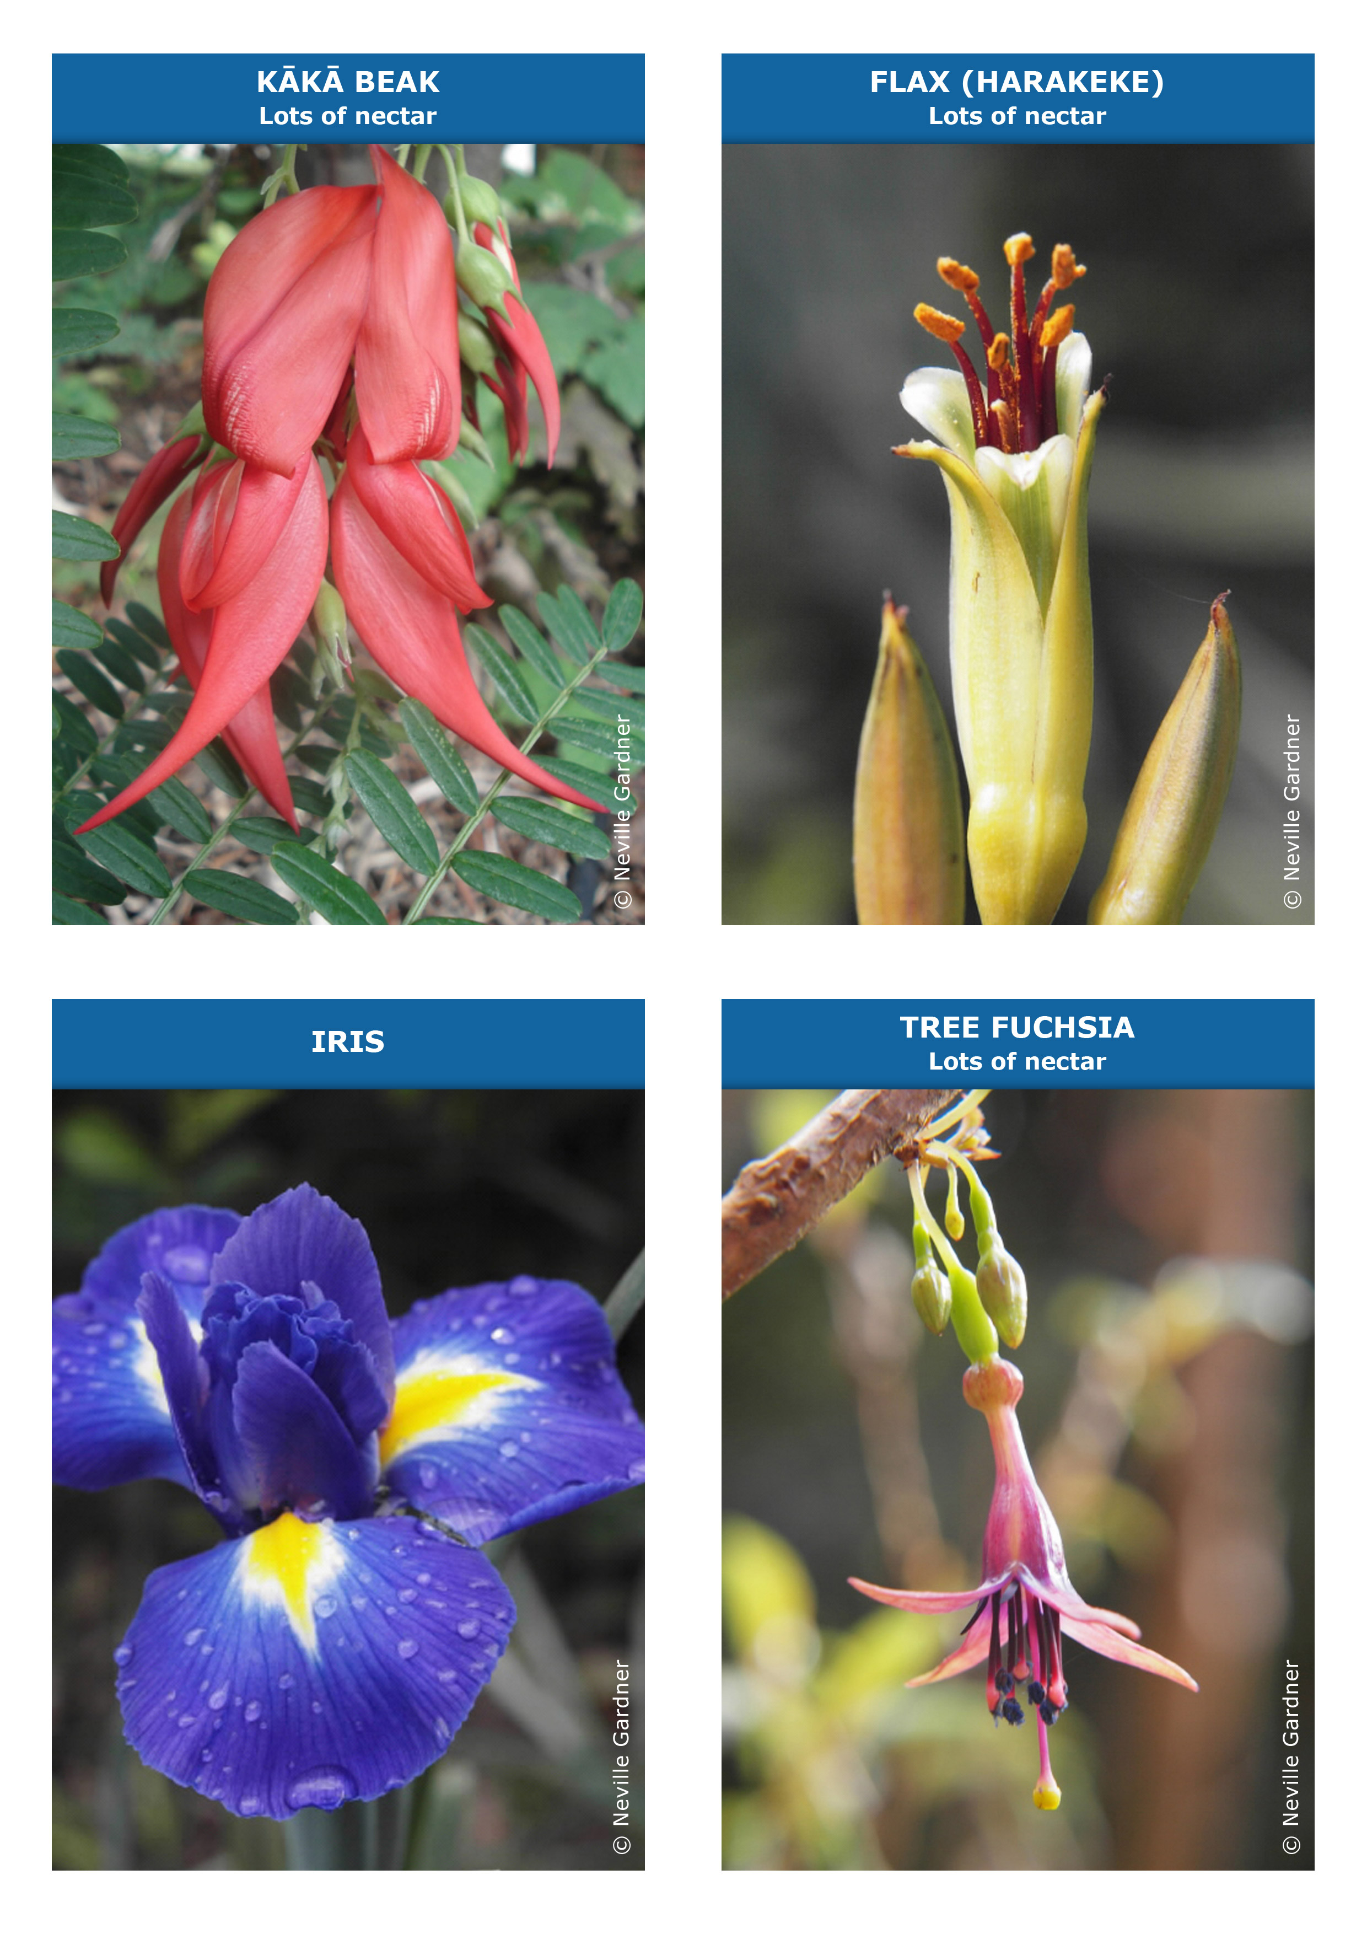
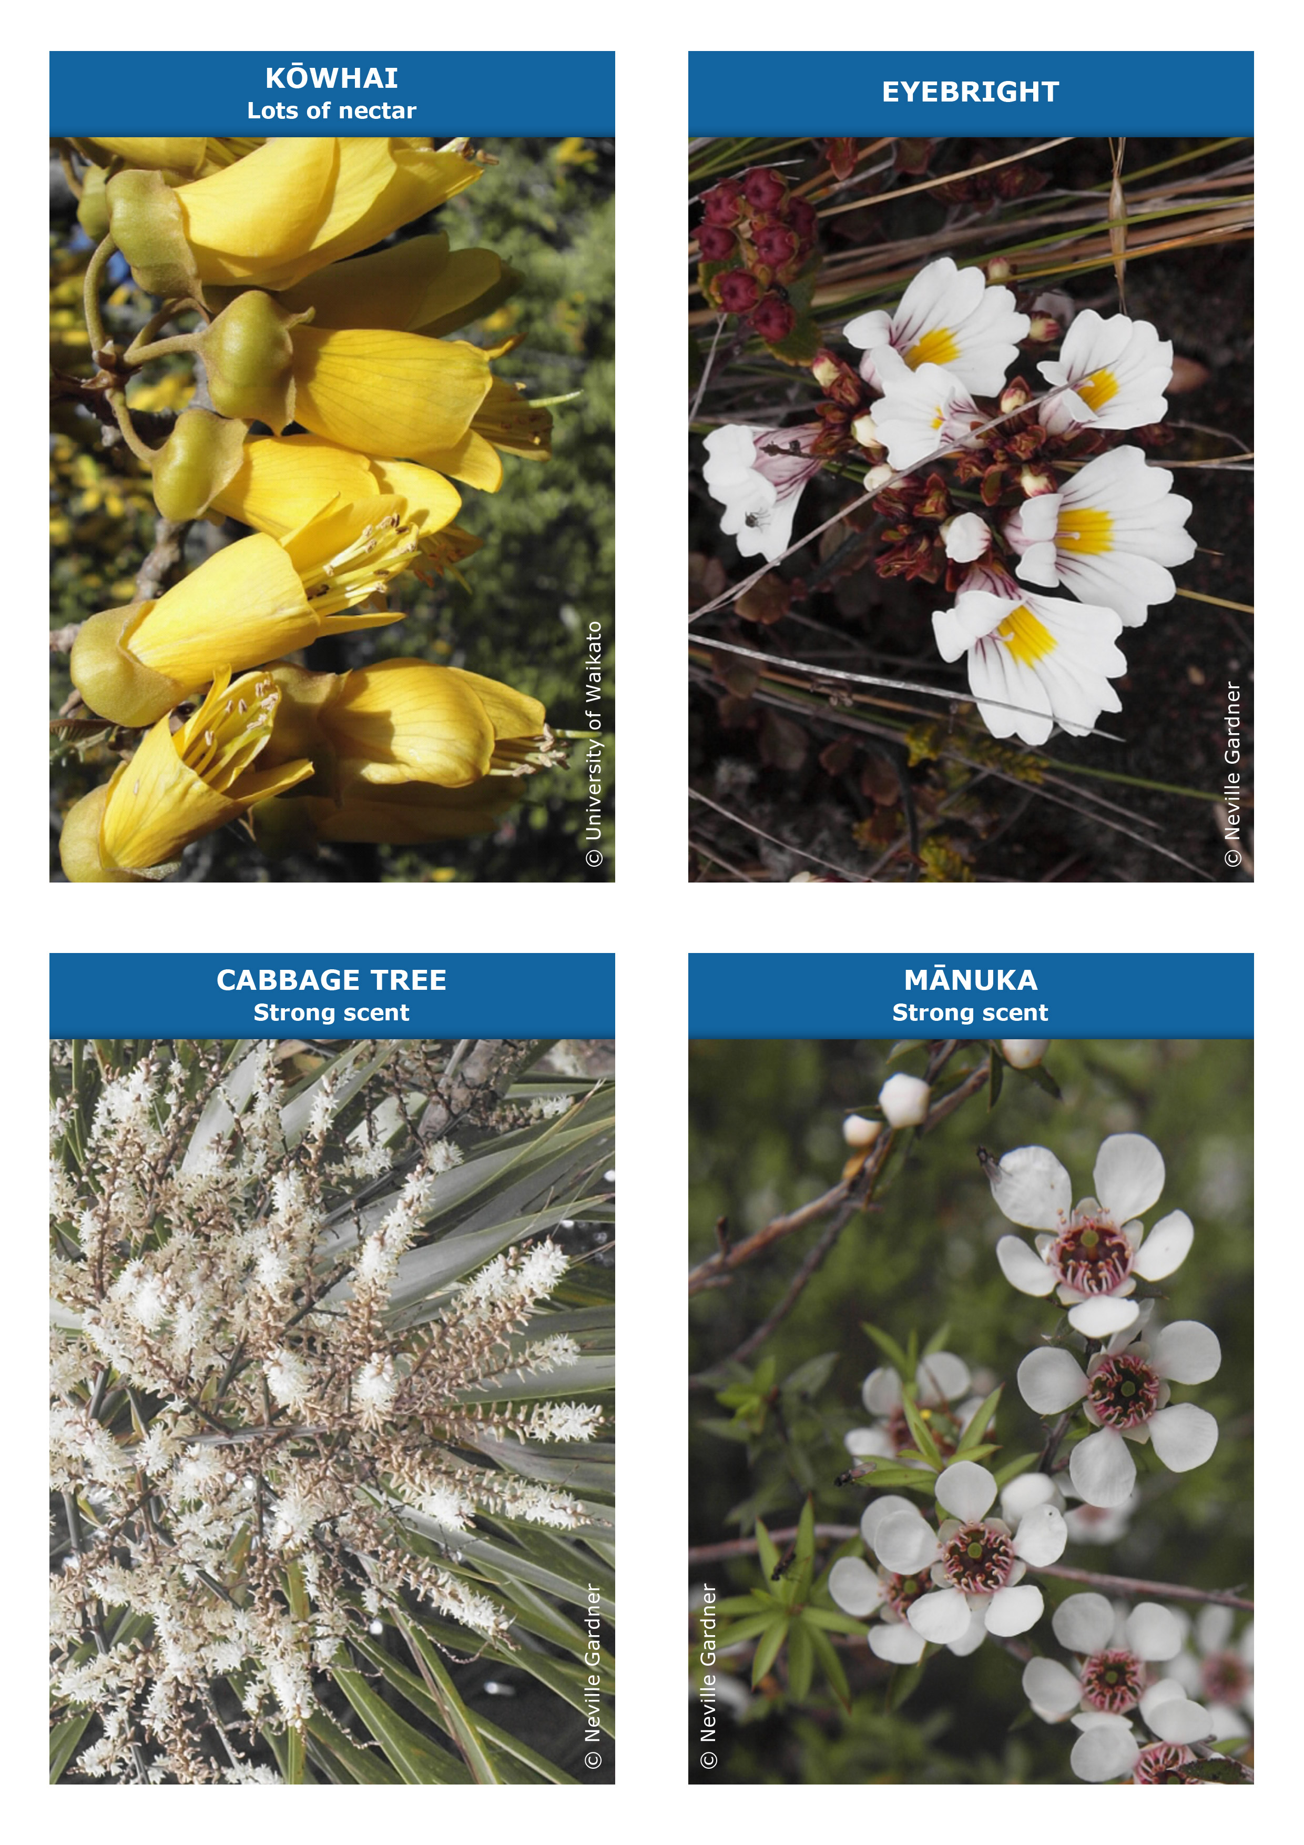
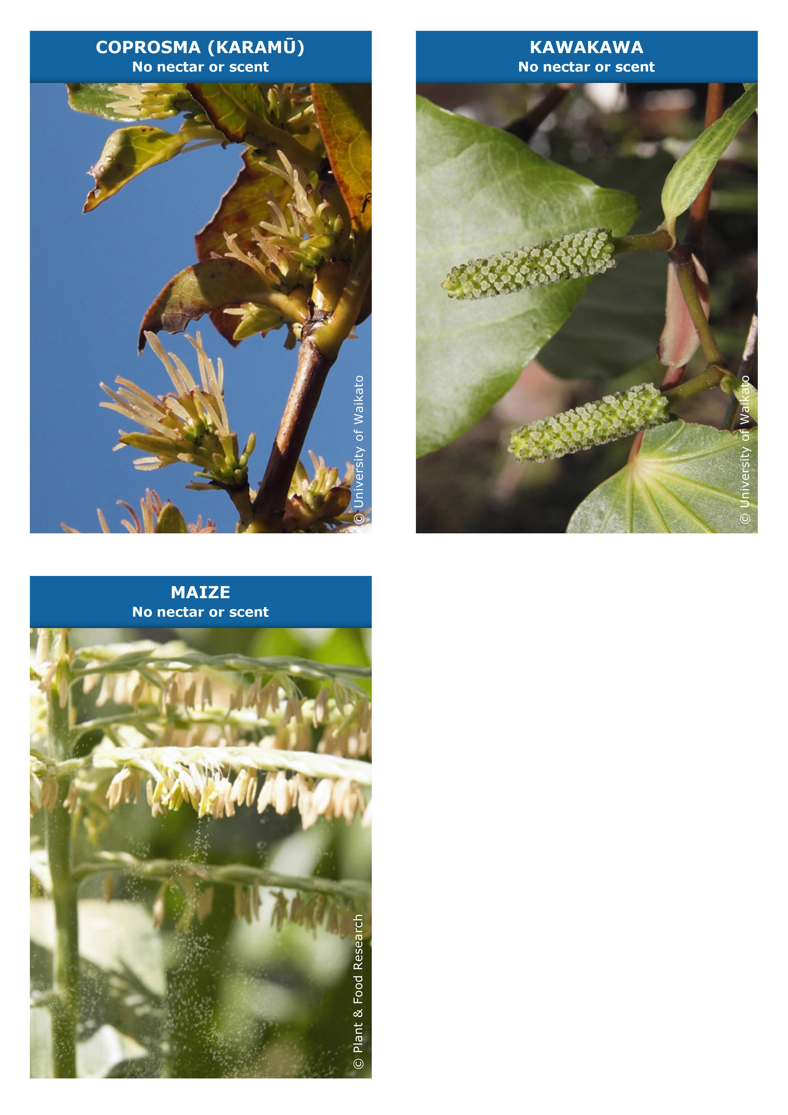
Pollinator cards

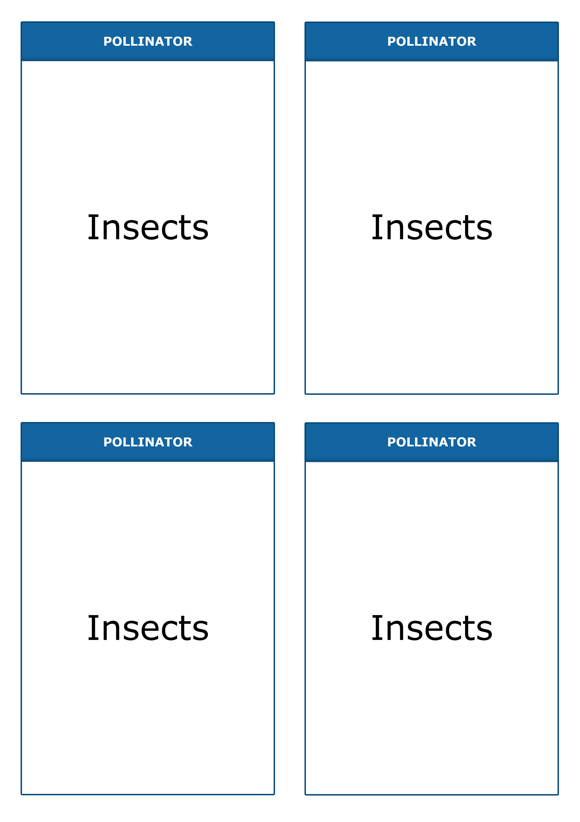
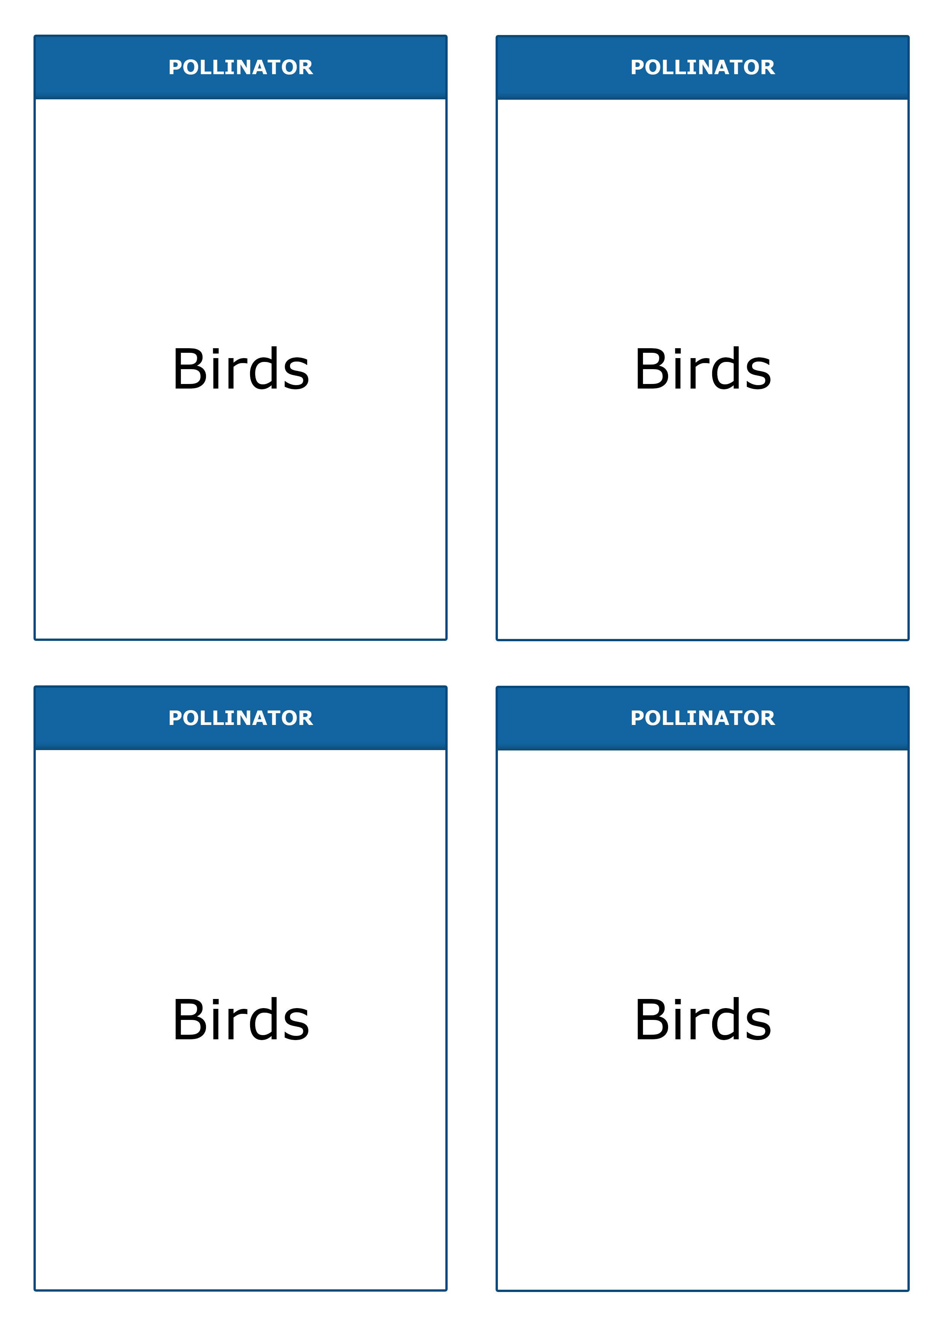
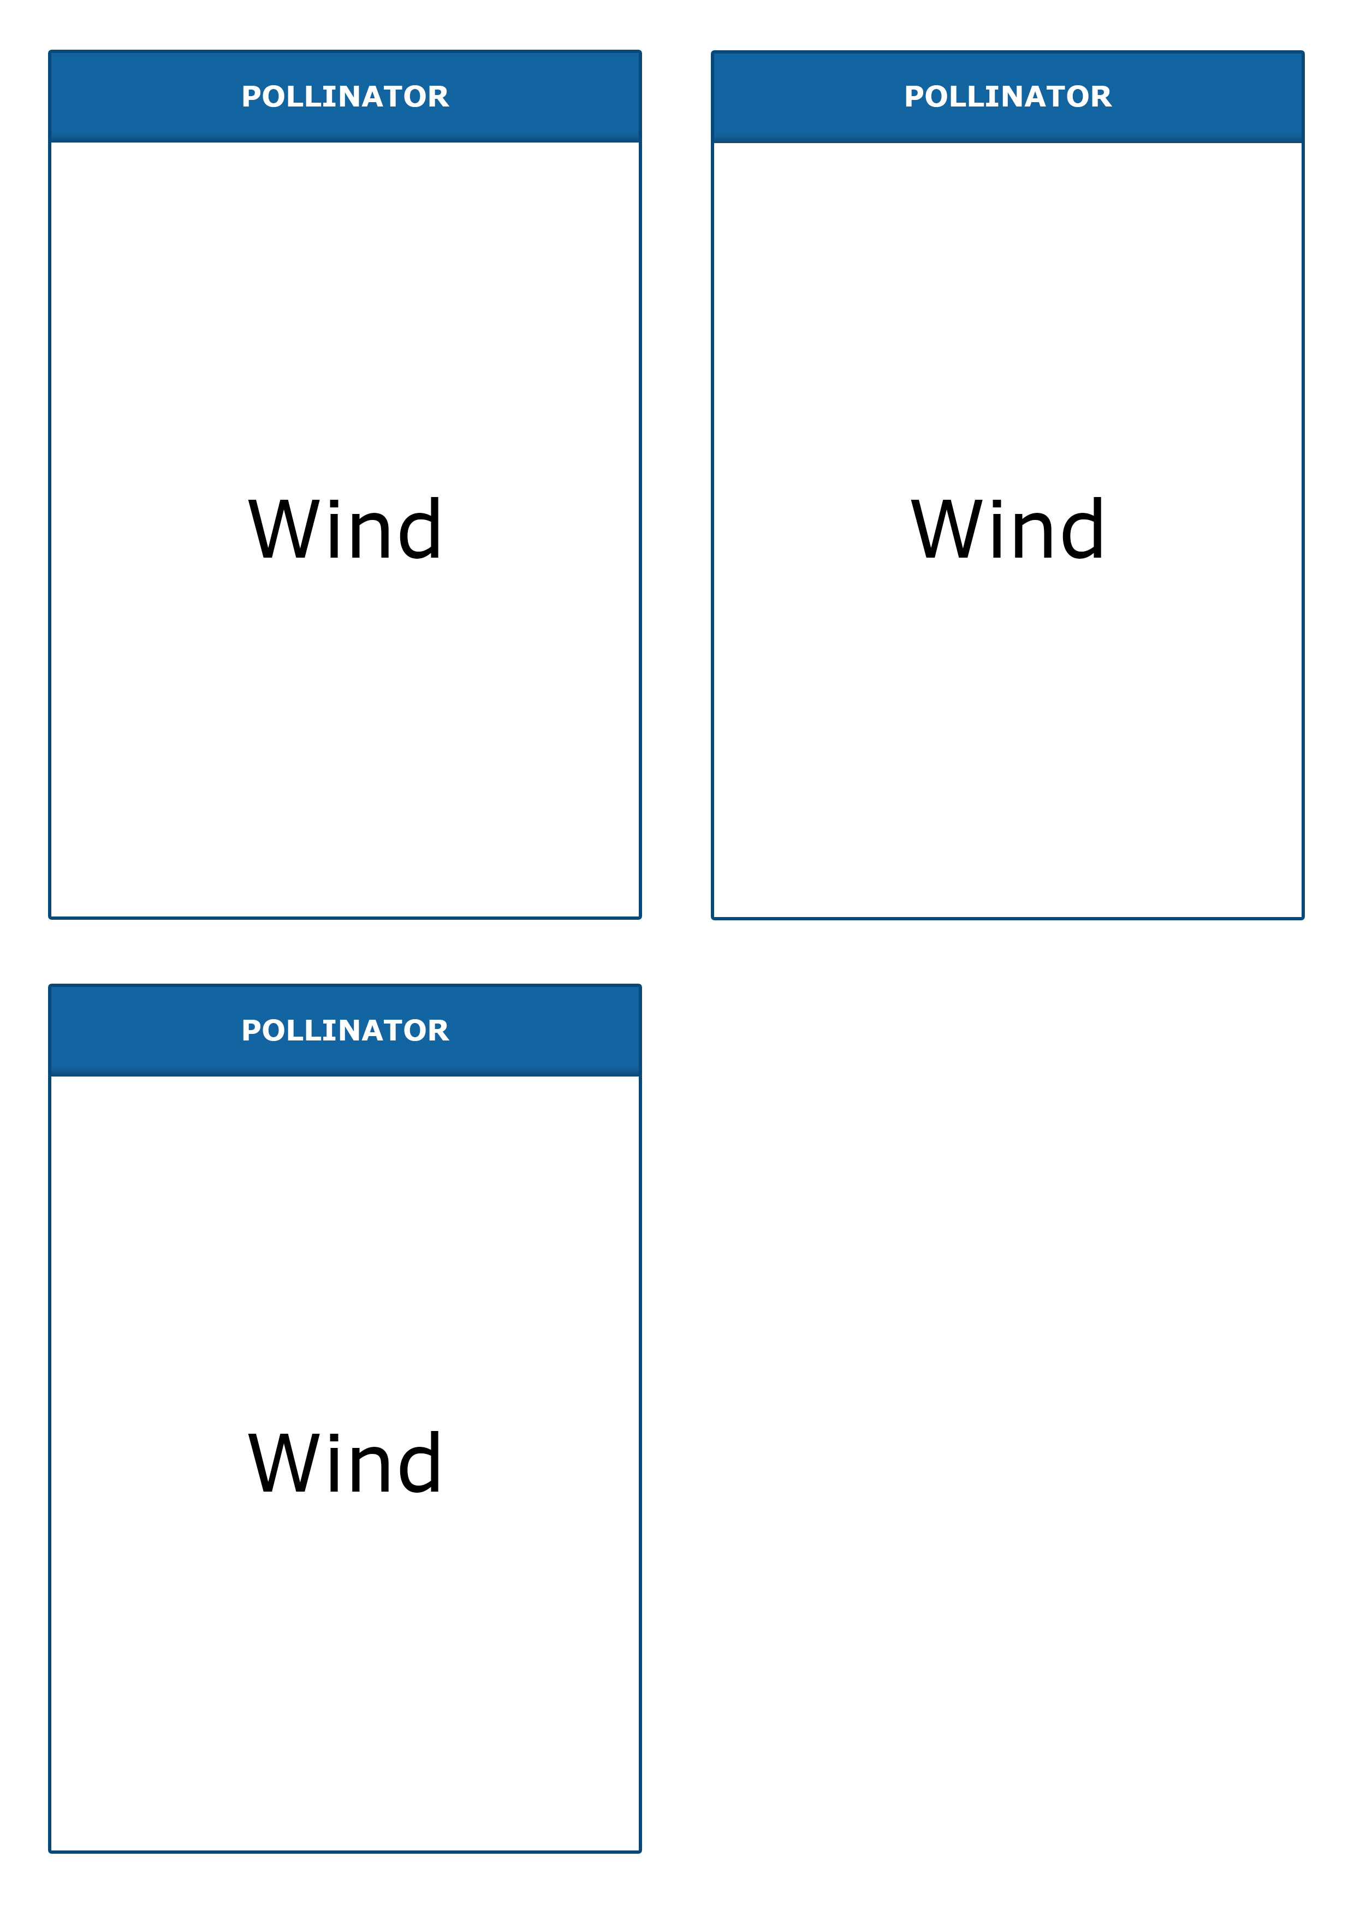
Teacher answer sheet

Flower | Pollinator | More information
Maize | Wind | Maize, also known as sweetcorn, is a grass that has been introduced to New Zealand as a food crop. It has separate male and female flowers on the same plant. The picture shows lots of male flowers releasing masses of pollen. There are no petals, and you can see the anthers hanging down, exposed to help the wind get at them.
Kawakawa | Wind | A New Zealand native, this has male and female flowers on separate plants. The picture shows two female spikes containing many flowers. Each pale patch is a stigma, and there are no petals.
Coprosma  (karamū) | Wind | A New Zealand native, this has male and female flowers on separate plants. The picture is of female flowers, which do not have petals. The stigmas are large and prominent to help catch pollen from the wind.
Mānuka | Insects | The flowers of this New Zealand native have white petals – a common sign of insect-pollination. They have a strong scent that attracts insects such as honey bees to the anthers and stigmas at the centre.
Eyebright | Insects | This New Zealand native is common in alpine areas, where the white petals stand out against the dark rocks. There are landing lines on the petals to guide insects into the flower.
Cabbage tree | Insects | This familiar tree has masses of small white flowers – a common sign of insect pollination. Flowers have a strong scent, which attracts moths at night and other insects during the day.
Iris | Insects | This introduced plant is common in gardens. It has clear landing lines to help guide insects inside the flower. New Zealand native irises do not have these markings.
Kōwhai | Birds | Most varieties of the native kōwhai have masses of bright yellow flowers that come out in spring before the leaves appear and hide them. Kōwhai flowers also have lots of nectar at the bottom of tubes formed by petals. When birds with long beaks reach in to get this reward, they brush against the anthers and stigmas and transfer pollen.
Flax  (harakeke) | Birds | Native flax flowers may not be as brightly coloured as other bird-pollinated flowers, but they have lots of nectar at the bottom of tubes formed by petals. When birds with long beaks, such as tūī, reach in to get this reward, they brush against the anthers and stigmas and transfer pollen.
Kākā beak | Birds | A typical bird-pollinated flower – big and red with lots of nectar.
Tree fuchsia | Birds | These native trees have no leaves over winter, and the flowers appear in spring before leaves emerge and hide them. The flowers have lots of nectar for birds, but use colour in an unusual way. The flowers are greenish when ready for pollination and turn red/purple afterwards to tell birds to stop coming.

