ACTIVITY: Light and sight: true or false?

Activity idea

In this activity, students participate in an interactive ‘true or false’ activity that highlights common alternative conceptions about light and sight. This activity can be done individually, in pairs or as a whole class.

By the end of this activity, students should be able to:
- clarify some of their current views about light and sight
- provide evidence to support their current views
- debate ideas with others who hold different views that may challenge their current thinking
- investigate some key light concepts including how light travels and how we see things.

Introduction/background notes
What you need
What to do
Extension ideas
Student handout: True or false?
True or false? – sample answers

Introduction/background

Light is a complex topic. Many students have already formed ideas about light and how they see things. Unless they have a chance to identify their current conceptions, they will be very reluctant to change these ideas.

Before carrying out this activity with your class, it is recommended that you read Alternative conceptions about light, which highlights some of the more common misunderstandings.

This activity can be used at the start of a Light and Sight unit to assess prior knowledge and at the end as an informal assessment activity.

What you need

- Access to the interactive graphic organiser or sufficient copies of the student handout True or false?
- Optional: Printed copies of the articles Light basics, Colours of light, Reflection of light, Refraction of light and How the eye focuses light.

What to do

- Allow students sufficient time to complete the interactive graphic organiser, either individually or in pairs using a computer or mobile learning device. This can also be a whole-class activity via an interactive whiteboard – encourage students to come up and move the statement cards to the appropriate box and to move a statement card if they do not agree with its position. Alternatively, use the paper-based version in the student handout True or false?

- Invite students to share their ideas with the class. Allow students a chance to argue their case for each of their answers.

- If appropriate, allow students time to research any statements they are unsure about. This research could be web-based or using the print-outs of the articles Light basics, Colours of light, Reflection of light, Refraction of light and How the eye focuses light.

Extension ideas

- If you have an interactive whiteboard with voting capability, you could set this up as an anonymous voting activity as a useful way to gauge the understanding of the class.
- Ask students to rewrite the false statements so that they read true. Discuss as a class.

Graphic organiser worksheet

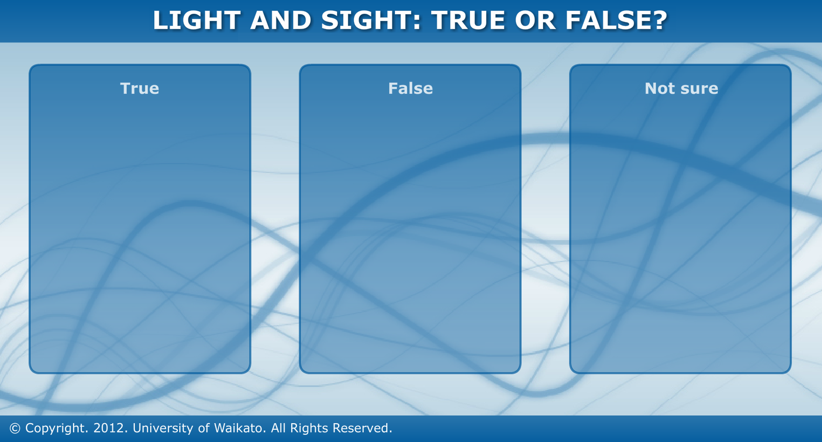

True or false?

Statement | True or false? | Comment
Light from the Sun can travel further than light from a candle

Cats can’t see anything at all in a totally darkened room

We can only see things that are making light

Light keeps travelling until it hits something

Light from the Sun takes over 8 minutes to reach the Earth

A shadow is a dark reflection

For us to see things, light has to enter our eyes

A pencil appears to bend in water because the water bends it

We see things as light travels from our eyes to an object

A lens helps to form images because it bends light

Light from a candle does not travel as far during the daytime

A red object looks red because it only reflects red light

True or false? – sample answers

Statement | True or false? | More information
Light from the Sun can travel further than light from a candle | F | Light always keeps travelling until it hits something else. Light from a candle can travel just as far as light from the Sun.
Cats can’t see anything at all in a totally darkened room | T | People, cats and most other animals can only see things that are producing light or that have light reflecting off them.
We can only see things that are making light | F | We can also see things that are light reflectors. Light from another source, such as the Sun, reflects off objects and travels to our eyes.
Light keeps travelling until it hits something | T | Light always keeps travelling until it hits something else. It can then be absorbed, reflected or change direction as it passes through that object.
Light from the Sun takes over 8 minutes to reach the Earth | T | Light takes about 8 minutes and 20 seconds to reach the Earth from the Sun. Reflected light from the Moon takes about 1 second to reach us.
A shadow is a dark reflection | F | A shadow is a region in space where light from a source has been blocked by an object. This can produce an outline of the object on a wall or on the ground, but this is different to an image produced in a mirror due to reflection.
For us to see things, light has to enter our eyes | T | We see things because light from an object travels into our eyes and forms an image on the retina at the back of our eyes.
A pencil appears to bend in water because the water bends it | F | Light reflects off the pencil. As the light crosses between the water and the air, it changes direction. This is called refraction. This causes us to see an image of the pencil in a different place that it actually is.
We see things because light travels from our eyes to the object we are looking at | F | We see objects because light travels from the object towards our eyes. It enters our eyes and forms an image on the retina at the back of our eyes.
A lens helps to form images because it bends light | T | As light passes through a lens, it changes direction. This is called refraction and is the reason that lenses help to form images.
Light from a candle does not travel as far during the daytime | F | Light travels the same distance whether it is daytime or night-time. It is just that we cannot see the effects of this light as clearly during the daytime because there is so much other light around.
A red object looks red because it only reflects red light | T | Coloured objects appear to be a certain colour because they absorb all colours apart from the colour we see. White objects reflect all colours equally. Black objects absorb all colours of light so there is very little light reflected for us to see.

