ACTIVITY: Investigating refraction and spearfishing

Activity idea

In this activity, students aim spears at a model of a fish in a container of water. When they move their spears towards the fish, they miss! This activity investigates refraction.

By the end of this activity, students should be able to:
- describe how the fish appears to be closer to the surface of the water than it actually is
- draw a diagram to show how the light coming from the fish bends (refracts) as it moves from water into air
- explain that this bending of light makes the fish appear to be in a different place than it is
- discuss the correct place to aim if you want to hit the fish
- recall the meaning of the term refraction.

Introduction/background notes
What you need
What to do
Extension ideas
Student handout: Let’s go spearfishing

Introduction/background

People who go spearfishing quickly learn that, if they want to hit the fish, they need to aim in front of where the fish appears to be. Actually, the fish is below where it appears to be. As light coming from the fish moves from water into air, it changes direction. This change of direction is called refraction and happens whenever light is moving into a different substance in which its speed becomes faster or slower. This activity introduces students to the science ideas of refraction. Refraction can cause things to appear to be in a different position than they actually are.

A common misconception
A lot of people see an image of a pencil or ruler or something else appearing to bend as it is placed in water. They assume that refraction is the apparent bending of the object. The object does not bend, and in fact, this can lead people to think that bending occurs in the opposite direction to what actually happens. In this activity, each spear appears to bend because light coming from each part of the spear refracts as it reaches the surface. This causes each point on the spear to seem to be closer to the surface than it actually is. Light coming from each point on the spear (or ruler or other object) behaves in the same way as light coming from the fish. This makes the ruler example a more difficult concept to understand.

What you need

- 4 x thin wooden skewers (250 mm long x 2.5 mm diameter)
- 2-litre plastic container
- 4 x 70 mm lengths of a thin drinking straw (or roll paper into thin 70 mm tubes just wide enough for the skewers to go through)
- Small model fish (can make this from Blu-Tack)
- Blu-Tack (or similar)
- Copies of the student handout Let’s go spearfishing

What to do

- Hand out copies of the student handout Let’s go spearfishing. Discuss the activity with the students and assist them to gather the materials they need to conduct the experiment.

- Discuss their findings.
Scientific explanation  - We can see things because light is coming from them and into our eyes. The Sun is a light source. | 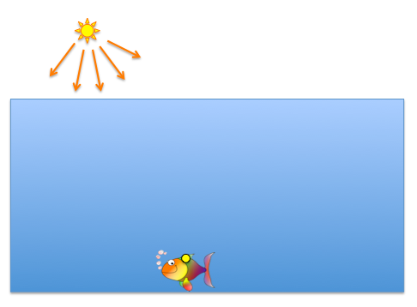
- If some light from the Sun or clouds or sky travels into the water, it reflects off the fish. The light travels in all directions from the fish. At night-time, when there is very little light, fish cannot be easily seen because there is not enough light reflecting off them. | 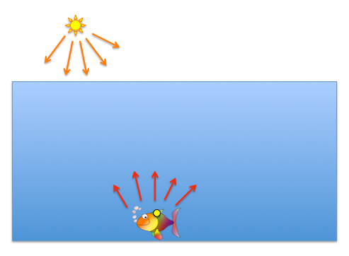
- To think about where the fish appears to be for someone who is looking at it from above the water, we need to think about what happens to each ray of light as it reaches the surface. Whenever light passes from one transparent substance (such as water) into another transparent substance (such as air) it changes speed and direction. This change of direction is called refraction. | 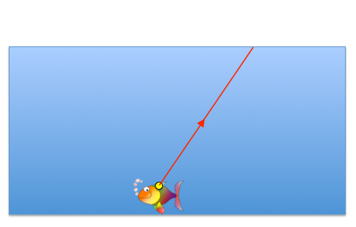
- To work out the direction that the ray of light will travel, it is best to draw in the point that each ray of light appears to come from. Each ray of light that reaches the surface of the water will change direction so that it appears to come from the point marked just above the fish. This is the position where the fish appears to be.  - Draw a dotted line from this point to the point where the ray meets the surface of the water. The ray of light travels directly away from this line as it continues into the air. Anybody seeing this ray of light sees that it appears to come from the point directly above the fish and along the path of the yellow dotted line. | 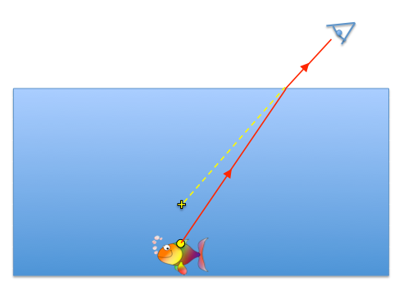
- This can be repeated for a second ray that comes from the fish. | 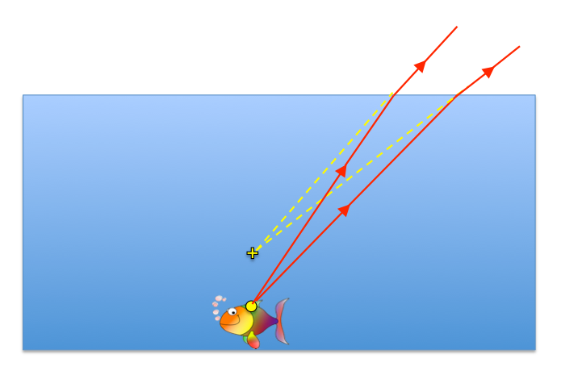
- And for a third ray. Anybody looking at the fish from any position will see that the rays appear to come from the same point above the fish. This point is called the apparent position. | 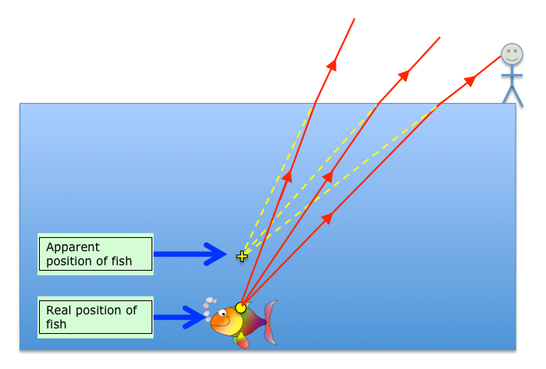
- Even if someone is looking at the fish from the other direction, the rays still appear to come from this same point. This is why any person who is trying to spear a fish needs to aim at a point directly beneath where the fish appears to be.  Note that the apparent position of the fish actually becomes closer to the surface for rays that are viewed at angles further away from the fish. When a person is viewing from a position more directly above the fish, its apparent position is three-quarters of the actual depth of the water. To estimate the actual depth of the fish, estimate how deep it appears to be and add and extra one-third of this distance. | 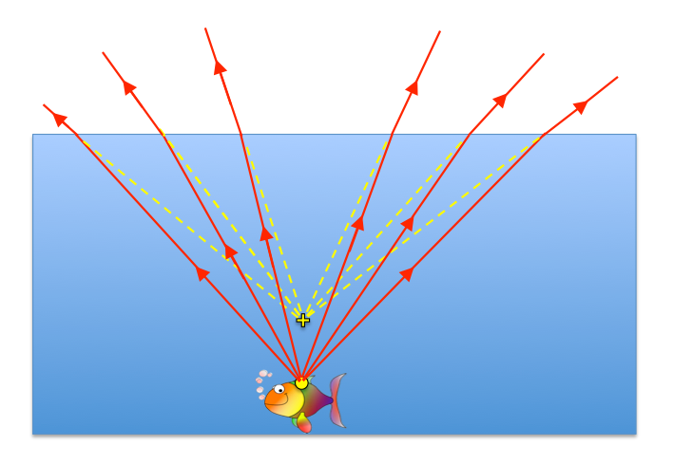

Extension ideas

For a more accurate calculation of where the fish appears to be, you may like to use the Angle of refraction calculator:
- For each ray that reaches the surface, draw a normal line at 90° to the surface. Measure the angle of incidence for each ray (angle between the ray and the normal).
- Select substance 1 as water and substance 2 as air.
- Enter the angle of incidence and record the calculated angle of refraction.
- Measure this angle of refraction carefully for each ray and draw each refracted ray above the surface.
- Draw a dotted line back from each ray to show where it appeared to come from.

Ask students what they think will happen if a laser pointer is pointed through the straw. Will it hit the fish or not?
- Carefully aim one of the straws at the mark on the fish.
- Turn on the laser pointer and see what happens. (A laser light that shines through one of the straws will hit the fish! This is because light entering the water also refracts. The light from the laser bends down towards the fish and follows exactly the same path as light that came from the fish.)

Note: It is not recommended for students to use laser pointers at any stage for light experiments. Laser light is dangerous and can cause permanent eye damage if it shines directly into a person’s eye.

Student handout: Let’s go spearfishing

- Attach the model fish to the bottom of the container with some Blu-Tack.  - Ensure there is a single mark at the top of the fish to aim at.  - Fill the container with water 3 cm from the top.  - Place some Blu-Tack and a straw at the top of each side of the container. Ensure that each straw remains well above the water without touching the surface.  - Look through each straw and adjust its position to aim at the marked point on the fish.  - Fix each straw into position with the Blu-Tack.  - Without moving the angle of the straw, carefully push a spear (wooden skewer) through one of the straws. Note whether you hit the fish.  - Repeat for the other spears. Carefully retract each of the spears slightly until they all meet at a point. This is the point where the fish appears to be for any observer.  - Place a ruler in the container to measure the distance from the surface of the water to this point and record it. This is the apparent depth of the fish.  - Measure the distance from the fish to the surface of the water and record it. This is the actual depth of the fish.  - Now try to aim each straw so that your spear will actually hit the fish. Do not move your straw while you are placing your spear!  - See which of your friends has the best aim. | 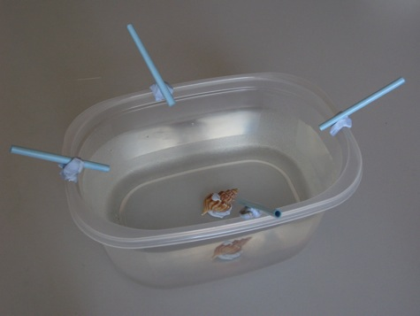
 | 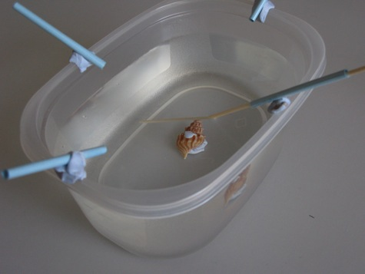
 | 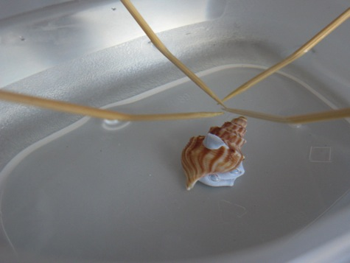

Complete the following

- Draw a diagram of your fish in the container of water. Ensure you draw the water level and fish at the correct measured depths.

- Draw your straws and spears in the diagram above to show what happened.

- Carefully measure the correct distance from the surface of the water to the mark on the fish and to where the spears actually hit.

Distance from surface of water to fish = _______ mm

Distance from surface of water to where the spears cross = _______ mm
(this is the point where the fish appears to be)

- Why do you think the fish was not where it appeared to be?

- What do you think happened to each ray of light that came from the fish?

- Define refraction.

- List some other examples of where refraction occurs.

- How much deeper is the actual position of the fish compared with its apparent position? Express this as a fraction.

- What advice would you give to a person trying to spear a fish to help them hit the fish?

- If light from a torch or a laser were to shine through a straw that has been aimed at the fish, what would happen? Explain your answer.

- Complete the diagram below to show what happens to each ray of light coming from the fish that causes the fish to appear to be in a different position.

