ACTIVITY: Pinhole cameras and eyes

Activity idea

In this activity, students make a pinhole camera and see images formed on an internal screen. They then use a lens and see brighter and sharper images. This models the human eye.

By the end of this activity, students should be able to:
- describe how a pinhole camera produces small upside-down images
- explain why a larger hole produces brighter but less focused images
- observe how a lens placed in front of the pinhole camera produces a bright and sharply focused image
- compare a pinhole camera with a human eye, describing similarities and differences.

Introduction/background notes
What you need
What to do
Discussion questions
Student instructions: Make a pinhole camera

Introduction/background

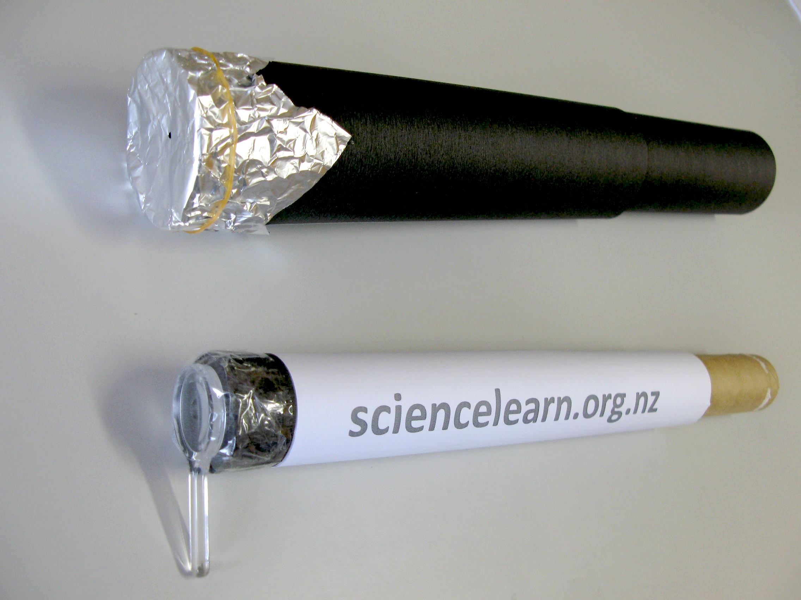
This activity works best on a sunny day. Students build a pinhole camera and view the image formed on the internal screen. They see an image that is inverted (upside down) and smaller than the object. As they gradually increase the size of the pinhole, they see that the image becomes brighter and blurrier.

When the size of the hole is very large, a lot of light will enter the pinhole camera but no image will be seen.

Students then place a magnifying lens in front of the hole and see that the image becomes bright and sharply focused. This activity helps students understand how the cornea and lens of the eye focus light to form images on the retina at the back of their eyes.

What you need

- Copies of the student instructions Make a pinhole camera.
- 2 x hollow cylinders of slightly different diameters so that one fits snugly inside the other (tubes from plastic wrap and paper towels can fit together well) OR 2 x sheets of A3 size black cartridge paper
- 1 x translucent plastic bag – plastic bags from the supermarket vegetable aisle work well
- Aluminium foil
- Rubber band
- Cellotape
- Magnifying lens

What to do

- Hand out copies of the student instructions Make a pinhole camera. Discuss the activity with the students and assist them to gather the materials they need and construct their pinhole cameras.

- Discuss their findings and the questions below.

Discussion questions  - How is the image formed?  Light comes from the sun and travels outwards in all directions.  When light from the sun hits an object such as a person, the light reflects (bounces) off the person and travels in all directions.  Each ray of light keeps travelling in a straight line until it hits something else.  If some of the light goes through the pinhole, it will keep travelling in a straight line until it hits the screen at the back of the pinhole camera.  This forms a brighter spot on the screen. | 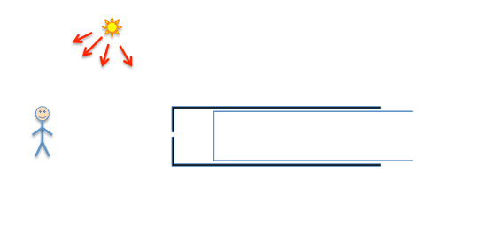
 | 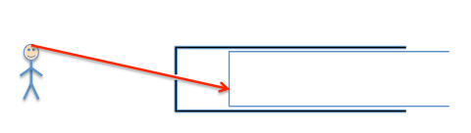
- Why is the image upside down?  Light that has come from a person’s head will hit a part of the screen that is lower down. | 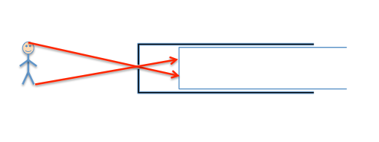
Light that has come from a person’s feet will hit a part of the screen that is higher up.  This means that there is an image seen on the screen. This image will be upside down (inverted) and smaller. | 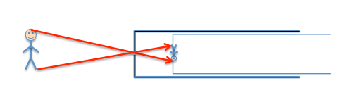
- Why does the image become bigger but not so bright when the screen is moved further away from the hole?  If the screen is close to the hole, the image will be smaller and brighter.  If the screen is moved further away from the hole, the image will appear larger.  It will not be as bright because the light has been spread out over a larger area. | 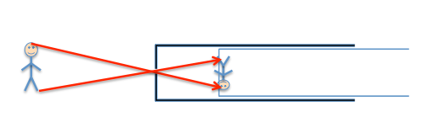
- Why do several images appear when there are several pinholes?  This is because light passing through each pinhole forms its own image. If the pinholes are fairly small, each image will appear to be quite well focused. | 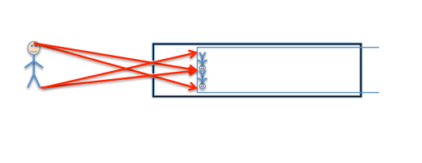
- Why does the image become brighter but blurrier when the hole is bigger?  If a larger hole is used, the light that has come from the person’s head will now hit a wider part of the screen. This means that the image of the person will now be unfocused. The image will be brighter because more light is now hitting the screen. | 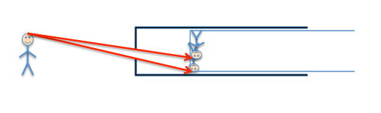
If the hole is very large, there will be a lot of light entering the pinhole camera, but no image will be seen at all. | 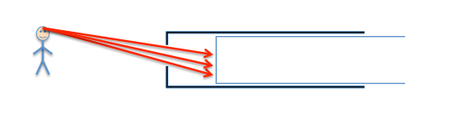
- How does the lens cause the image to become sharply focused?  If a lens is placed in front of the hole, the light rays that have come from the person’s head will now be focused towards a single point on the screen again. This makes the image appear bright and sharply focused. | 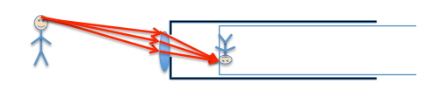

If a lens is used but the screen is moved so that the image is slightly blurry, placing a smaller hole in front of the lens makes the image more focused again. This is similar to squinting your eyes to let less light in so that an image appears more focused. This can also be seen if you bring a page too close to your eyes so that the words appear out of focus. Make a tiny hole between the tips of two fingers and your thumb. Holding this hole close to your eye will make the words appear in focus again.

This effect is similar to using a smaller hole on the pinhole camera. The light rays entering your eye will be less spread out so things will appear more in focus. People with poor eyesight can see things more clearly in bright light because the pupils of their eyes form smaller holes to let less light into the eye. Because the light entering the eye is now less spread out, the image seen will appear more sharply focused.

- In what ways is this model (with lens in place) similar to the human eye?

- Both have an image formed on a screen.
- Both have a lens system to focus the light sharply.
- An upside down image is created.
- Both images are in colour.
- If a lot of light is let in, the image will be brighter.
- If the hole is smaller (for the eye, that is controlled by the iris) then the image will be more in focus.

- In what ways is it different to the human eye?

- The retina of the eye contains light receptors that convert the light into an electrical signal. This signal is passed along the optic nerve to the brain. It is the brain that interprets these signals as an image.
- The eye is filled with fluid to bring the focal point much further forwards.
- The eye changes focus by adjusting the shape of the internal soft lens.
- The pinhole camera with the lens can bring things into focus by moving the position of the screen.

- What causes short-sightedness? How can this model be used to demonstrate short-sightedness? What sort of lens is needed to bring the image back into focus for a short-sighted person?

Short-sightedness can be modelled by moving the screen slightly further away from the hole so that a slightly blurry image is seen. For short-sighted people, the rays of light focus at a point in front of the retina (screen of the eye). To make the rays focus a bit further back, a slightly concave lens can be used to make the rays spread out a bit more before they enter the eye.

- What causes long-sightedness? How can this model be used to demonstrate long-sightedness? What sort of lens is needed to bring the image back into focus for a long-sighted person?

The opposite happens for a long-sighted person. A convex lens is needed to make the rays focus inwards a bit more before entering the eye. This makes the image focus a bit further forwards.
Make a pinhole camera

- Roll one sheet of black A3 paper into a hollow cylinder of 30 cm length with a diameter of approximately 7 cm and tape along the entire length of the tube.

- Place translucent plastic across one end of the tube you have made (or the tube from plastic wrap) so that it is flat with no wrinkles. Hold it in place with a rubber band. This forms the screen on which the image will be projected. Trim the excess plastic and then tape the plastic all the way around the tube to hold it taut and in place. Remove the rubber band.

- Roll the second sheet of black A3 paper around the first tube (or use the tube from the paper towels). Ensure that it is a snug fit, but so that the inside tube can still slide easily within the outside tube.

- Cut a square of aluminium foil approximately 10 x 10 cm. Place this to form a flat surface over the end of the outside tube. Fold the side of the aluminium foil around the outside of the tube and hold it in place with a rubber band. (You may use black paper instead of aluminium foil.)

- Use a sharp pencil to place a small hole of 1 mm diameter in the centre of the aluminium foil.

- Place the inner tube inside the outer tube. Ensure that the plastic screen is at the same end of the tube as the aluminium foil.

- Pull the inside screen slightly away from the aluminium foil so that the hole and the screen are separated.

- Point the hole towards a sunny scene and hold the open end to your eye. Make sure the Sun is behind you. You may like to look at a student standing about 5 metres in front of you. Observe what happens if the person waves their arms and jumps up and down.

- Record your observations. Investigate what happens to the size, brightness and sharpness of the image when:
- the screen is further or closer to the hole
- the size of the hole is increased
- several holes (e.g. 5 holes) are used at the same time
- a large hole (e.g. 1 cm diameter) is used
- a magnifying lens is placed over the same sized (e.g. 1 cm) large hole

- With the lens attached and the image sharply in focus:
- What happens when the screen is moved slightly further away from the hole?
- Without moving the screen, observe what happens to the focus of the image when a smaller hole (e.g. 3 mm diameter) is placed just in front of the lens.

