ACTIVITY: Investigating reflection

Activity idea

In this activity, students investigate specular and diffuse reflection by looking into a dark box and shining a torch at various objects, coloured paper and a mirror.

By the end of this activity, students should be able to:
- describe how objects can only be seen if there is a light source
- explain that diffuse reflection is when light reflects off a rough surface and travels in all different directions
- explain that specular reflection is when light reflects off a mirror or other shiny surface and that the angle of reflection is always the same as the angle of incidence
- describe how different coloured objects only reflect certain colours of light
- describe how different colours of reflected light can combine to produce new colours.

Introduction/background notes

What you need

What to do

Discussion questions

Student handout: What do you see?

What do you see? – scientific explanation

Introduction/background

Many students have little experience of a truly dark room. It is difficult to find such a room at a school. In this activity, a totally darkened environment is created using a cardboard box, such as a file box or a shoe box. Black paper is taped around the edges to prevent any light entering. A hole in one end of the box and a small cylinder of black paper is used as the viewer to see into the box.

A common alternative conception is that it is still possible for people (and even more so for cats) to see objects even if there is no light source present. In this activity, students see that even a brightly coloured object cannot be seen at all if there is no light present.

Another alternative conception is that objects need to be illuminated for them to be seen but that light stays on the object that is being illuminated. The scientists view is that light needs to reflect off an object and travel into our eyes in order for us to see it.

In this activity, students observe that light from the torch reflects off a coloured object and travels in all directions.

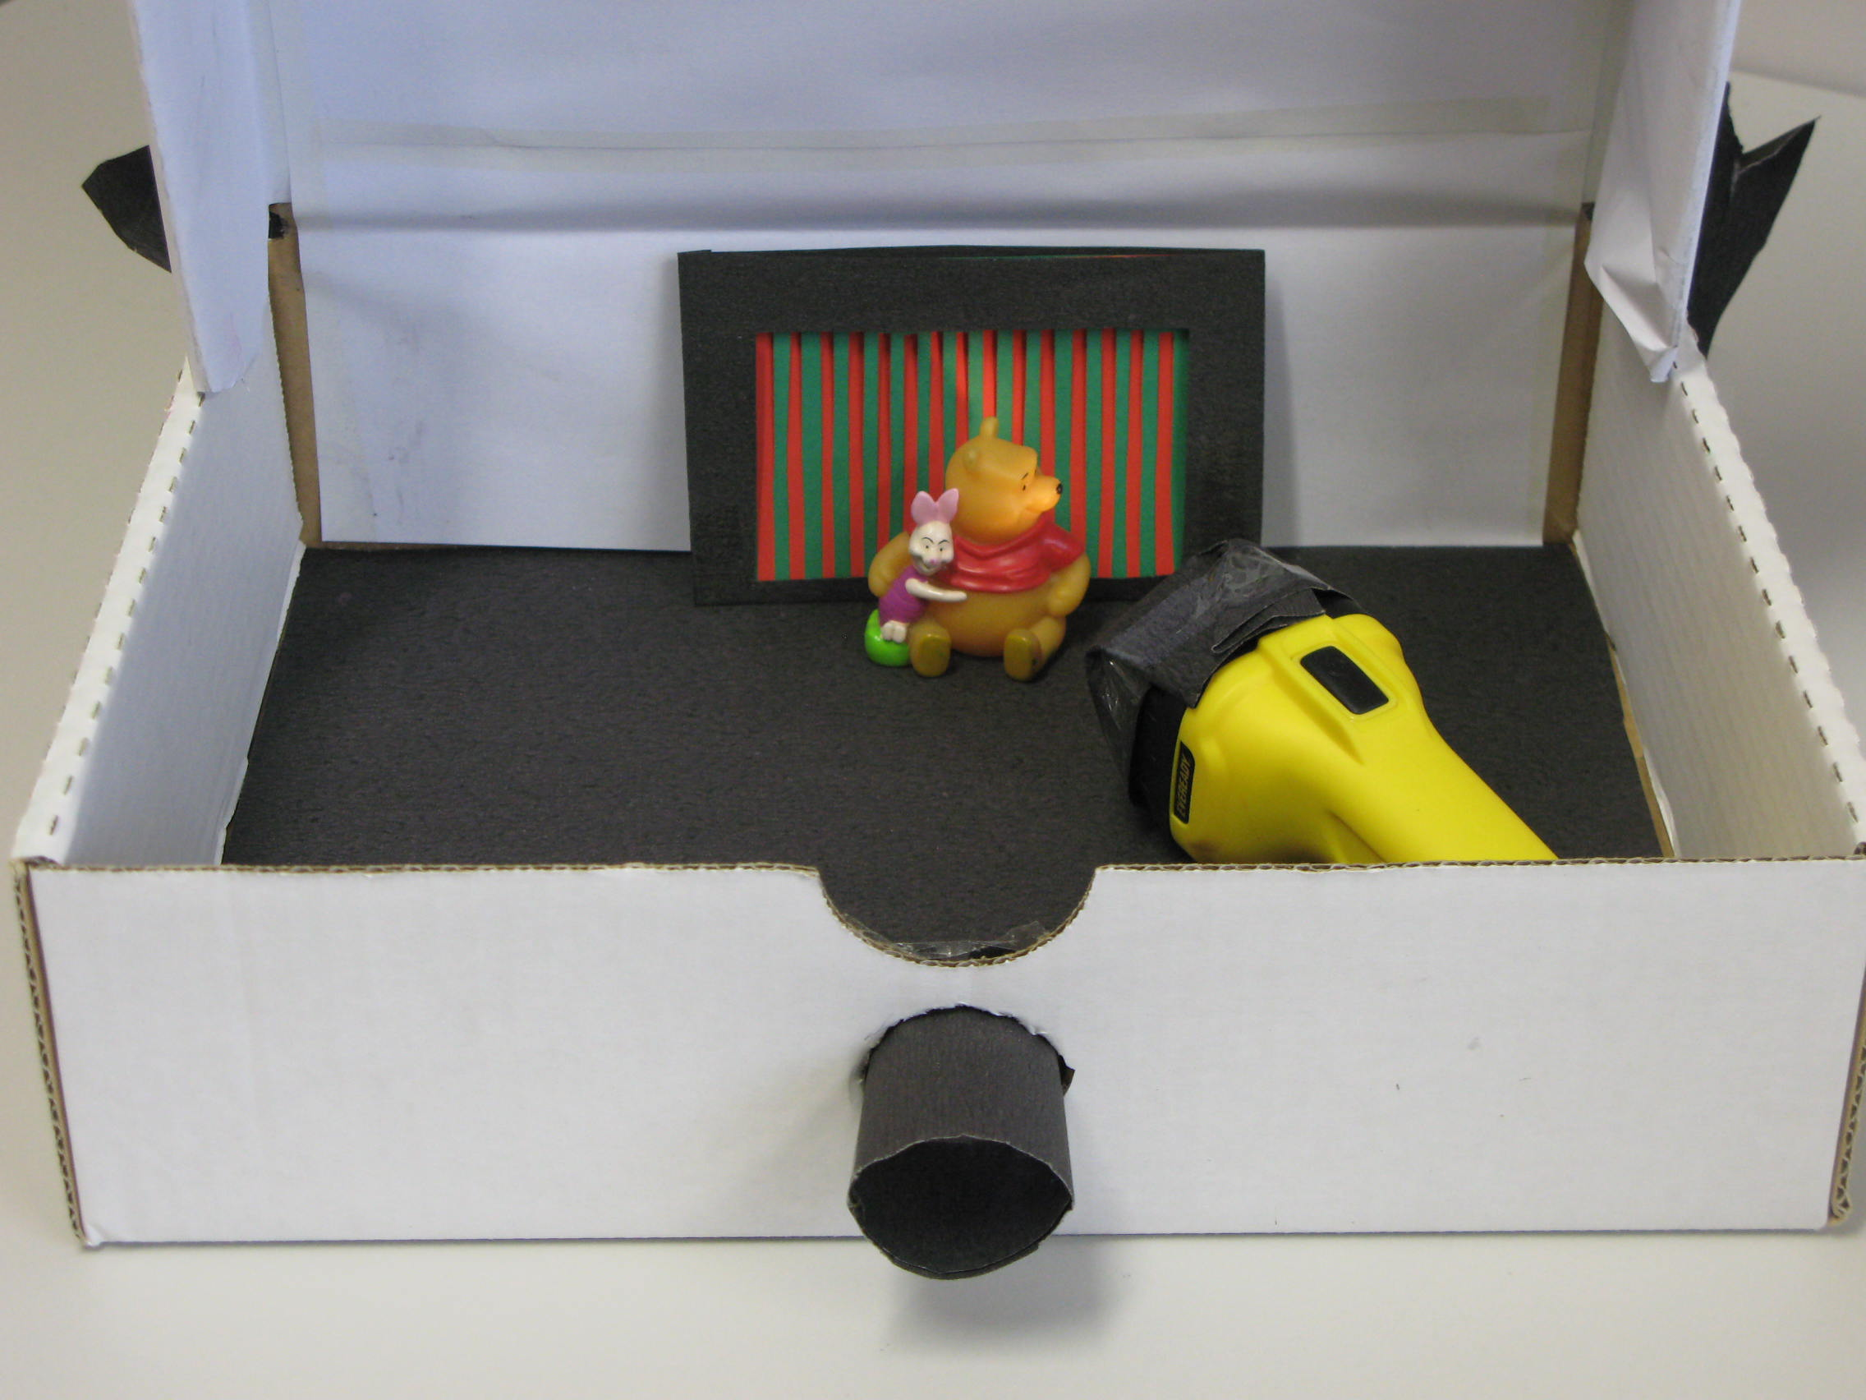
What you need

- Cardboard file box or shoe box
- Black paper
- Adhesive tape
- Torch
- Coloured paper – red, blue and green
- Scissors and craft knife
- Translucent plastic (for example, a plastic bag from the supermarket vegetable aisle)
- Blu-Tack
- Small mirror (or ruler with aluminium foil wrapped around it)
- 5 cm length of a wooden skewer (or a used match)
- Protractor
- Copies of the student handout What do you see?

What to do

- Prepare the reflection box for the students to use:
- Cut a 5 x 30 cm strip of black paper. Roll this into a hollow cylinder 5 cm long with a diameter of approximately 3.5 cm. Tape along the length of the tube.
- Mark and cut a 3.5 cm diameter hole in the middle of one end of the box.
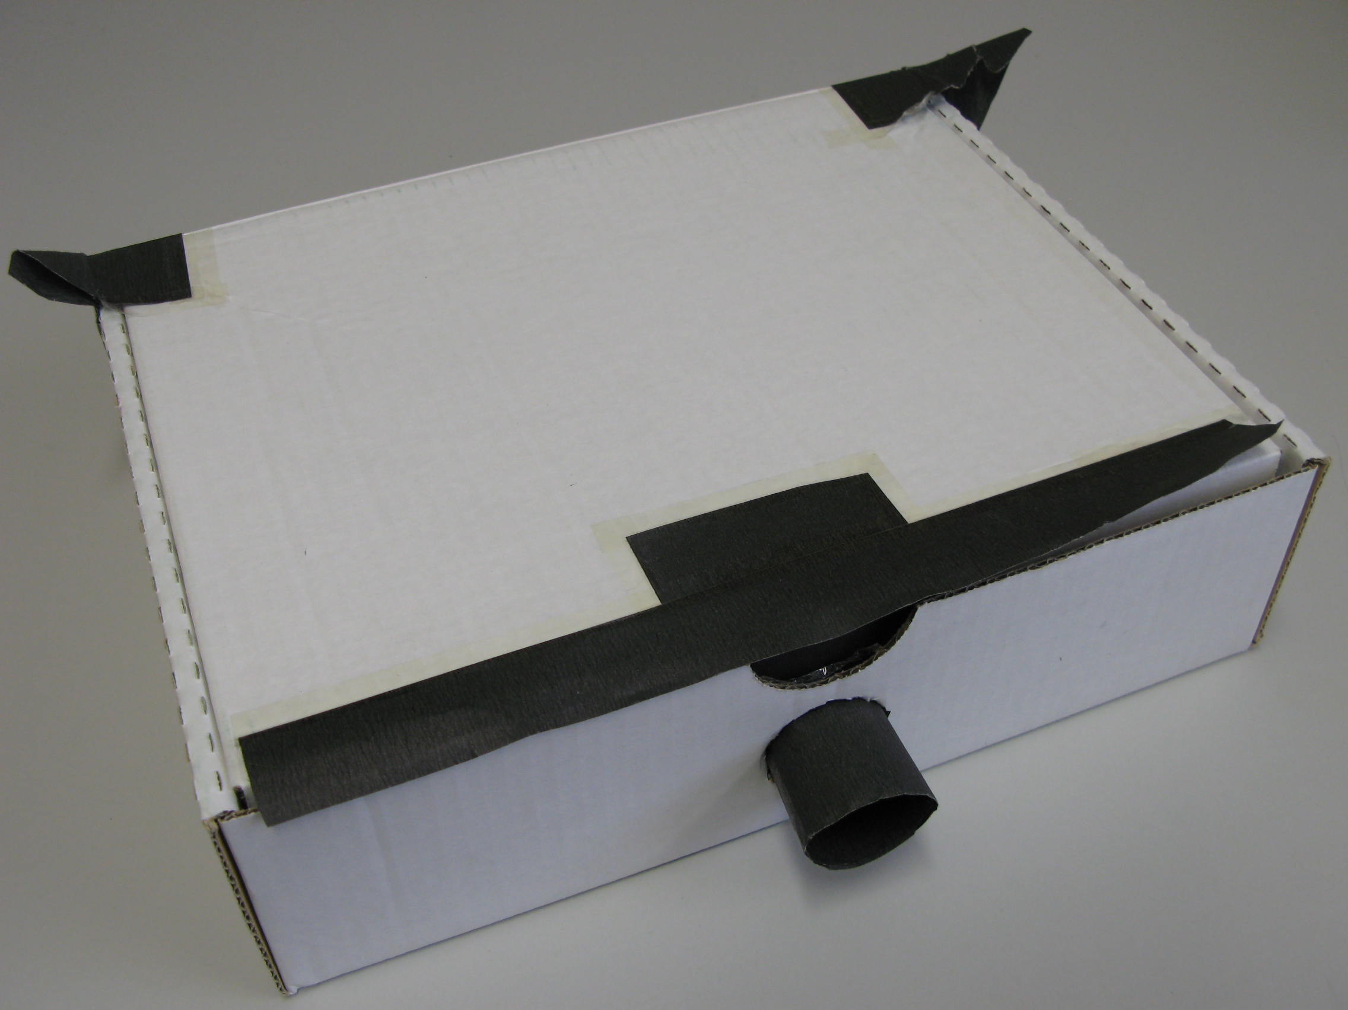
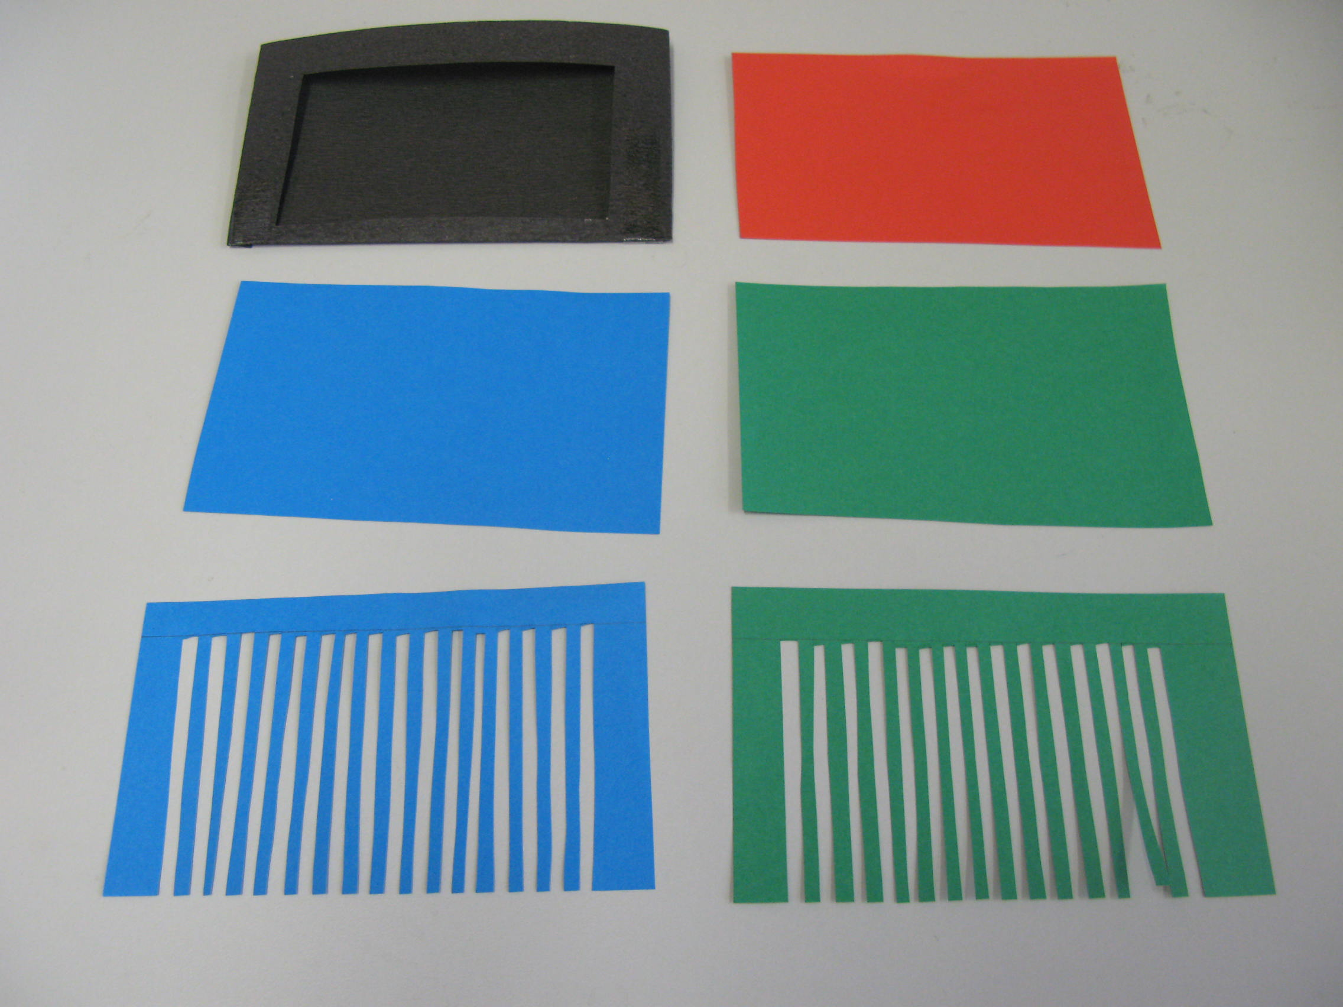
- Cut one end of the black cardboard tube into 1 cm strips (still attached), each slit about 1 cm apart. Insert this cut end of the tube into the hole in the box. Fold the edges over and tape all around to hold this in place. This tube now forms the viewing hole.
- With the lid of the box closed, look through the viewing tube to see if any light is entering the box. Use strips of black paper to tape over any parts of the box that are letting light through. Make sure the lid of the box can still be opened. The inside of the box should appear completely dark with no light visible at all.
- Cut coloured paper into rectangles approximately 13 x 8 cm (1 red, 2 blue, 2 green). For one of the blue cards and one of the green cards, rule a line 15 mm from the top. Cut lines from one of the long edges towards the marked line. Each cut should be approximately 3 mm apart. Cut every second strip off so the card looks like a comb.
- Cut a piece of black paper 17 x 15 cm. Fold this into an envelope that fits around all of the coloured cards. Cut a 10 x 6 cm window in the front of this envelope so that the coloured cards can be clearly seen but so that they are held in place. Fold the sides of the card around and tape these. The cards should now be able to be easily removed and replaced in any order.
- Cut a circle of paper approximately 3 cm larger than the diameter of the end of the torch. Cut lines from the edge to the diameter of the torch. Place the paper at the front end of the torch and fold the cut pieces down over the sides. Wrap a strip of tape around these strips to hold them to the shape of the torch. Cut a 2 cm hole in the centre of this cover so that the torch produces a narrow beam of light.

- Hand out copies of the handout What do you see? and have students complete steps 1–5.

- Cut a small square of translucent plastic approximately 8 x 8 cm and tape one edge to the top inside of the box half way between the viewing tube and the wall where the cards are placed. You may like to attach a couple of small pieces of Blu-Tack to the bottom corners so it hangs straight down. Have students complete steps 6–10 on the handout.
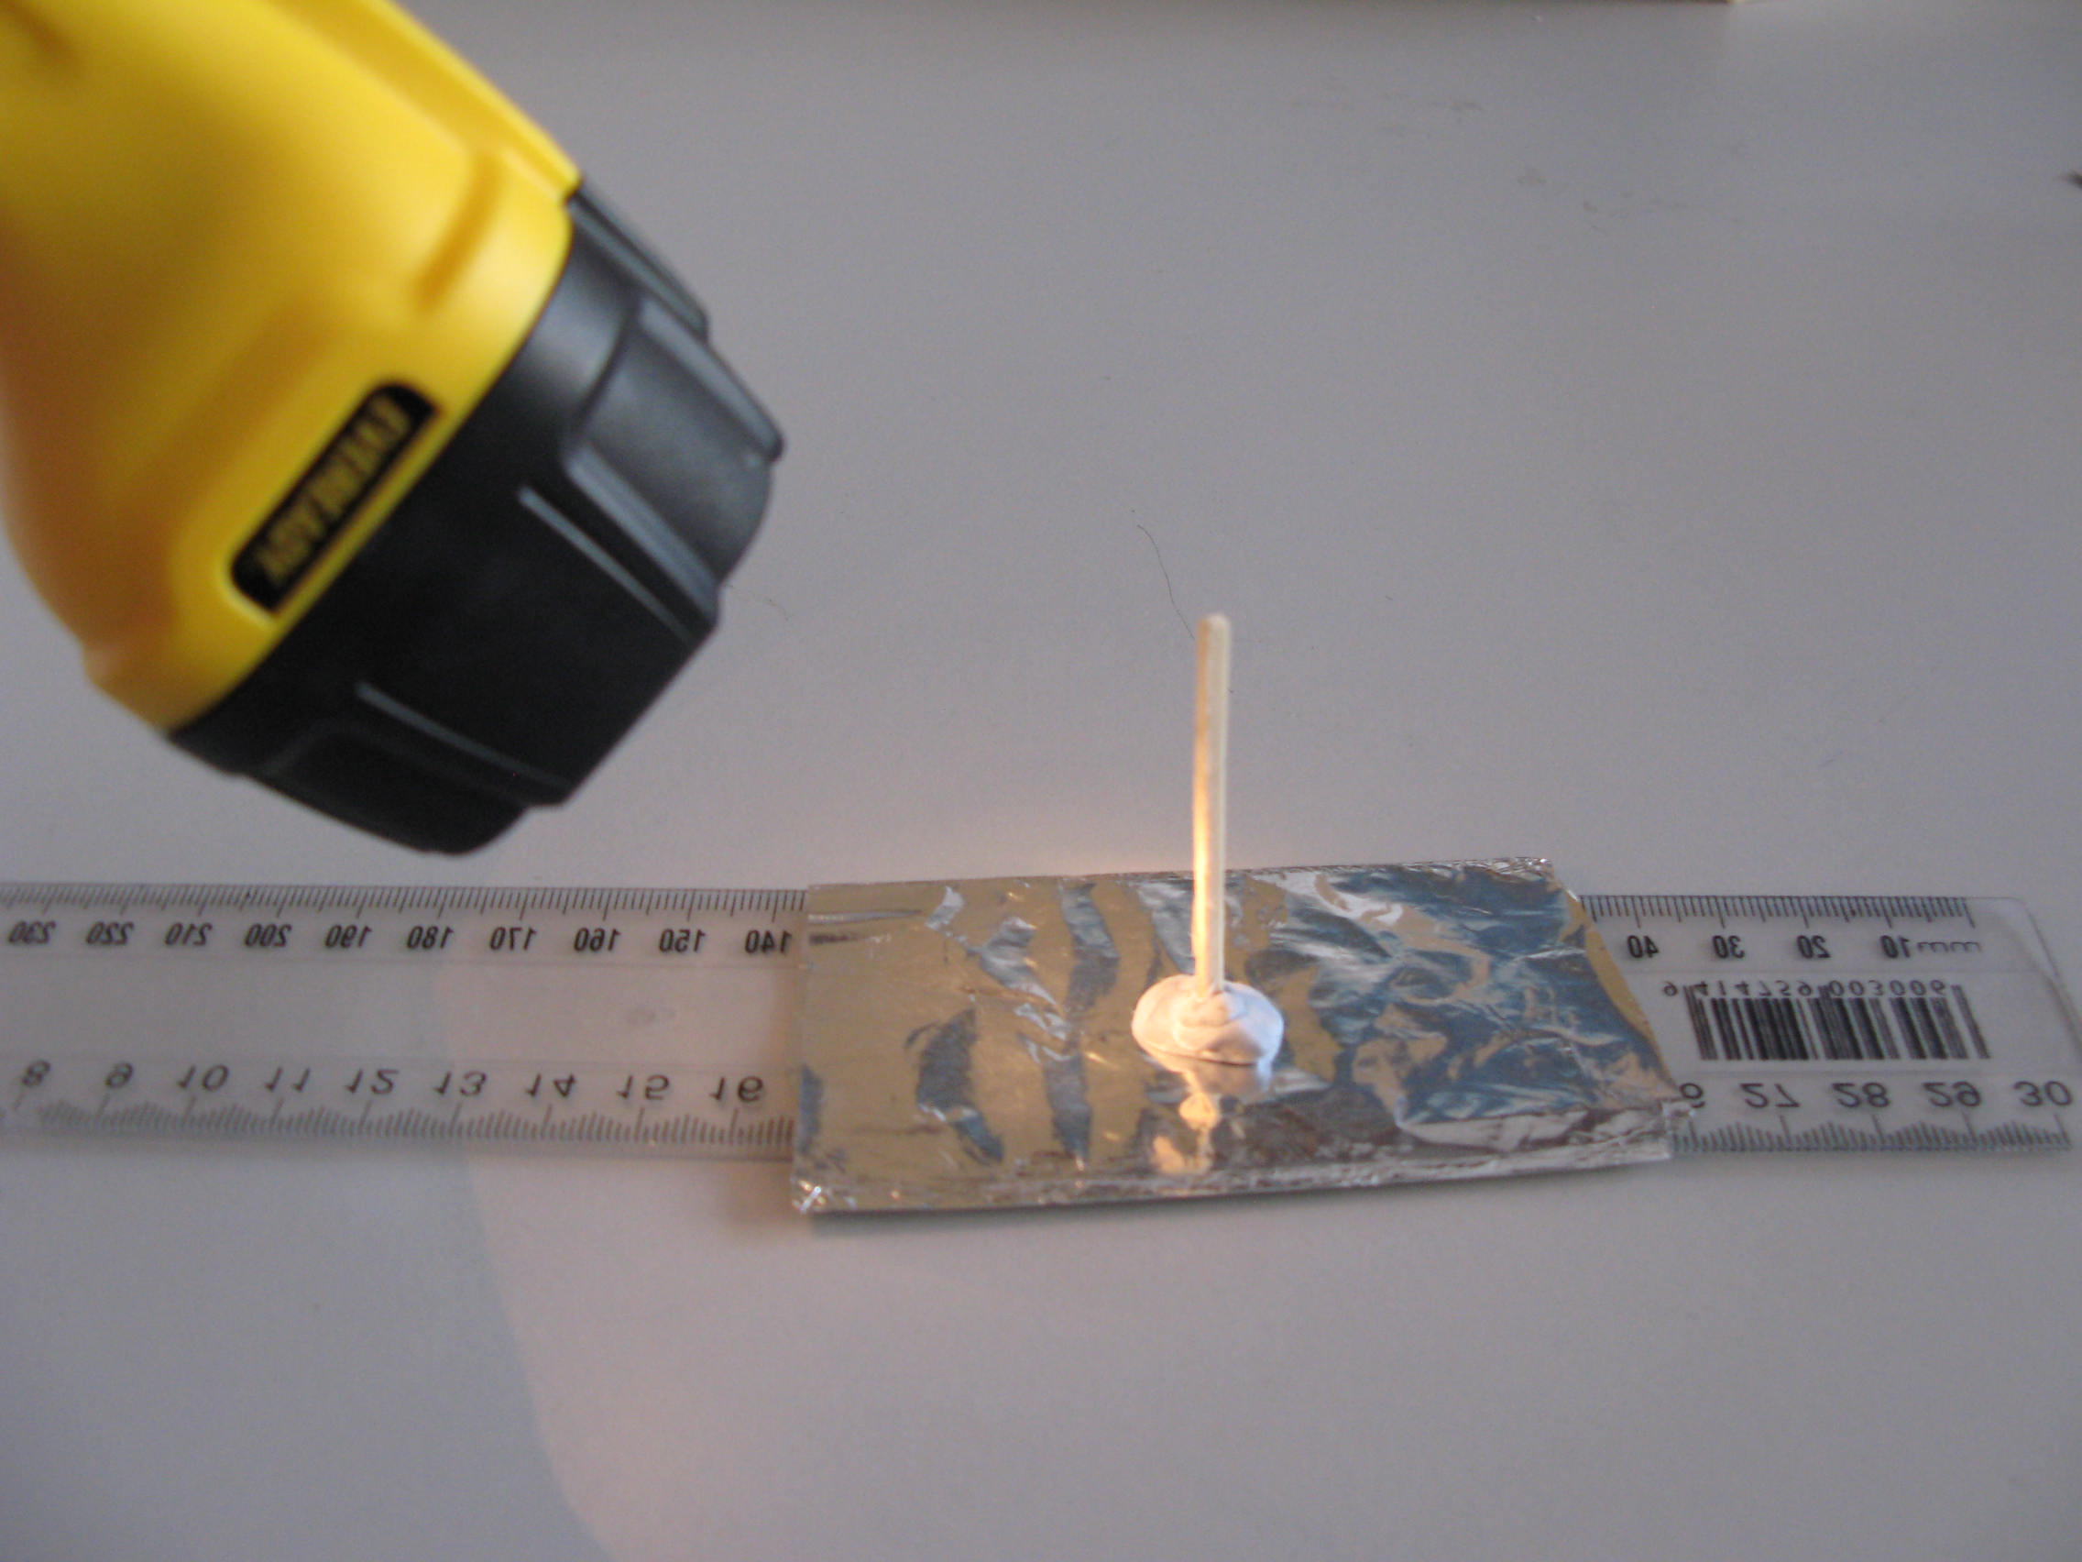
- To investigate specular (or regular) reflection, use a small piece of Blu-Tack to attach a wooden skewer (or used match) to the middle of a small flat mirror (or plastic ruler). The skewer needs to stick straight out at an angle of 90°. This skewer represents the ‘normal’ line from which all angles are measured. Have students complete step 11 on the handout.

Discussion questions

- Why can nothing be seen when the lid is closed and the torch is switched off?
- Would a cat or other animal see anything inside the box with the torch switched off?
- Why do shoes appear dull when they haven’t been polished for a while?
- What happens to shoes when we polish them to make them appear shiny?
- What are the differences between matte, semi-gloss and high-gloss paints?
- Why does a black car show up dirt easily?
- Why does a white car look cleaner for longer?
- Can objects have both specular and diffuse reflection at the same time?

What do you see?

For each of the following, write down what you think you will see and what you do see:

- Place a colourful object into the box at the side furthest from the viewing tube. Leave the torch switched off.

Prediction | Observation | Comments/questions/explanations
I think I will see… | I saw… | I was surprised that…  I think this happened because…

- Now turn the torch on.

Prediction | Observation | Comments/questions/explanations
I think I will see… | I saw… | I was surprised that…  I think this happened because…

- Place a red card into the box at the side furthest from the viewing tube. Torch switched on. What do you see on the roof of the box near the card?

Prediction | Observation | Comments/questions/explanations
I think I will see… | I saw… | I was surprised that…  I think this happened because…

- Place a blue card into the box at the side furthest from the viewing tube. Torch on.

Prediction | Observation | Comments/questions/explanations
I think I will see… | I saw… | I was surprised that…  I think this happened because…

- Place a green card into the box at the side furthest from the viewing tube. Torch on.

Prediction | Observation | Comments/questions/explanations
I think I will see… | I saw… | I was surprised that…  I think this happened because…

- What do you think you will see on a piece of plastic hanging down between the viewing tube and the wall when the torch is shining onto a red card and the lid of the box is closed?

Prediction | Observation | Comments/questions/explanations
I think I will see… | I saw… | I was surprised that…  I think this happened because…

- Still with the piece of plastic hanging down, place the slotted green card in front of the red card. What do you think you will see on the plastic when the lid is closed.

Prediction | Observation | Comments/questions/explanations
I think I will see… | I saw… | I was surprised that…  I think this happened because…

- What do you think you will see if green is placed in front of blue?

Prediction | Observation | Comments/questions/explanations
I think I will see… | I saw… | I was surprised that…  I think this happened because…

- What do you think you will see if blue is placed in front of red?

Prediction | Observation | Comments/questions/explanations
I think I will see… | I saw… | I was surprised that…  I think this happened because…

- Can you design a similar way of shining light onto red, green and blue at the same time? What do you think you will see?

- Shine a torch at an angle of about 45° onto the mirror. Use your hand to predict where the reflected light will go. Try again with different angles.
Measure and record the angle of incidence and angle of reflection for several different angles. Make sure all measurements are taken from the normal line (wooden stick at 90°).

Angle of incidence

Angle of reflection

What do you see? – scientific explanation

- Colourful object in box, torch switched off: Nothing will be visible. In order for us to see things, light from that object needs to travel to our eyes. For us to see an object, it either needs to be a light source (makes light) or a light reflector (light from somewhere else reflects off it).

- Torch on: Light from the torch hits the object and reflects off it in all directions. This is called diffuse (or irregular) reflection. Some of this light enters our eyes, and an image is formed on the retina at the back of our eyes. Signals are then sent along the optic nerve to our brain where these signals are interpreted as an image.

- Red card: A red object only reflects red light. All other colours are absorbed. The red light is reflected in all directions. It is interesting to see the inside of the box take on a red hue as the red light is then reflected from the inside walls and ceiling of the box.

- Blue card: See 3 above, except only blue light is reflected.

- Green card: See 3 above, except only green light is reflected.

- Red card, plastic screen hanging down: The red light from the red card is reflected in all directions. Some of this red light hits the plastic screen. The screen is translucent, which means that it lets light through, but it scatters it in all directions. The plastic screen appears red.
- Slotted green card in front of the red card: Both red and green light are reflected in all directions from the card. When these colours hit the plastic screen, it is scattered in all directions. If you look at the screen, all parts of the screen will be reflecting both green and red light towards your eye. When these two different colours hit the retina at the back of your eyes, two different signals are sent to the brain. Your brain ‘sees’ yellow. In reality, there is still both green and red, but your brain can’t tell the difference.

- Green and blue cards: The primary colours for mixing light are red, green and blue. When green and blue light hit our retina at the same time, our brain interprets this as a cyan colour.

- Blue and red cards: The primary colours for mixing light are red, green and blue. When red and blue light hit our retina at the same time, our brain interprets this as a magenta colour.

- Red, green and blue cards: The primary colours for mixing light are red, green and blue. When the right proportion of each of these colours hits our retina at the same time, our brain interprets this as white.

- Reflection from a mirror: Diffuse reflection takes place from a rough surface such as a person or a piece of paper or most of the other objects we see. Light hits the object and reflects off in all different directions. Specular reflection takes place from a smooth, shiny surface such as a mirror or polished glass or the surface of a lake. Whenever light hits this kind of surface, it reflects at the same angle as it hit. These angles are measured from the normal line (a line at 90° to the surface of the mirror at the point where the ray hits). The angle of incidence is always equal to the angle of reflection.

